I have HP workstation with Quadro K1200 Graphics card
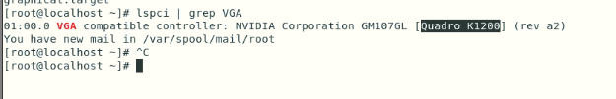
I am trying to install Nvidia Graphic card but it failing while installing.
I disabled the nouveau driver, Below is snap by connecting system via RDP
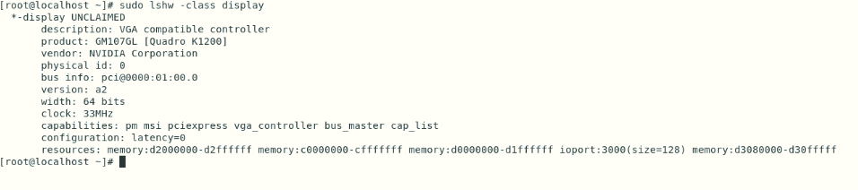
Now Connected with putty:-
- Make system in text mode.
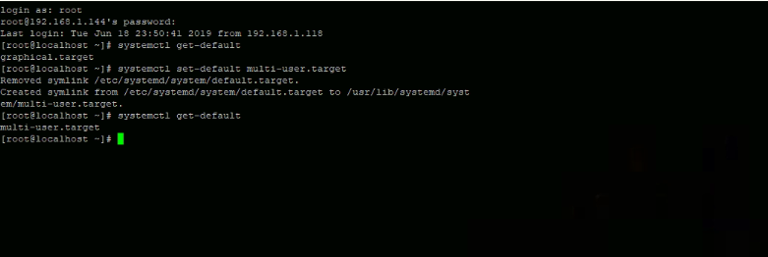
Check if nouveau driver is blacklist or not
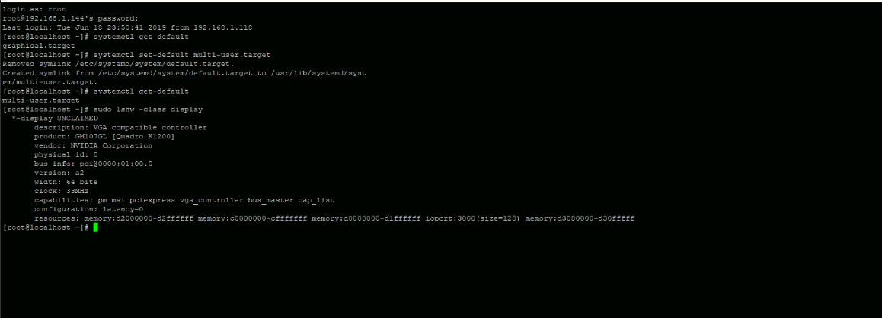

Go to folder where nvidia driver downloaded from location “https://www.nvidia.in/Download/index.aspx?lang=en-in” and run sh Nvidia
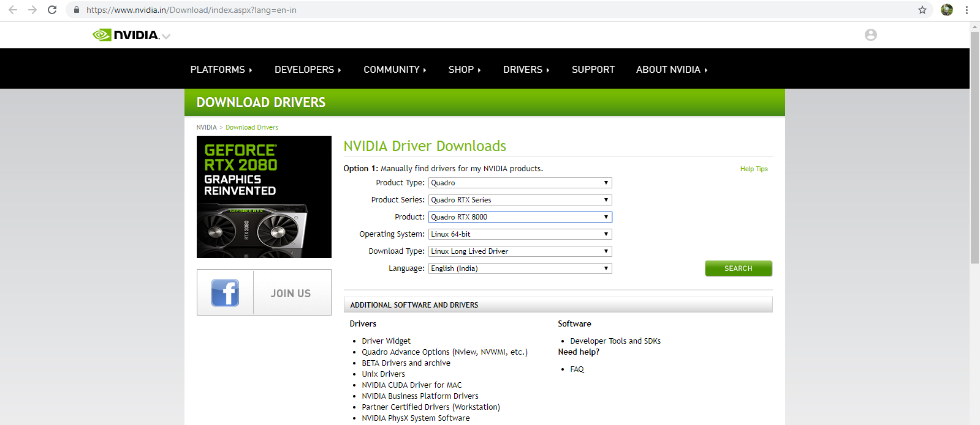

Installation started
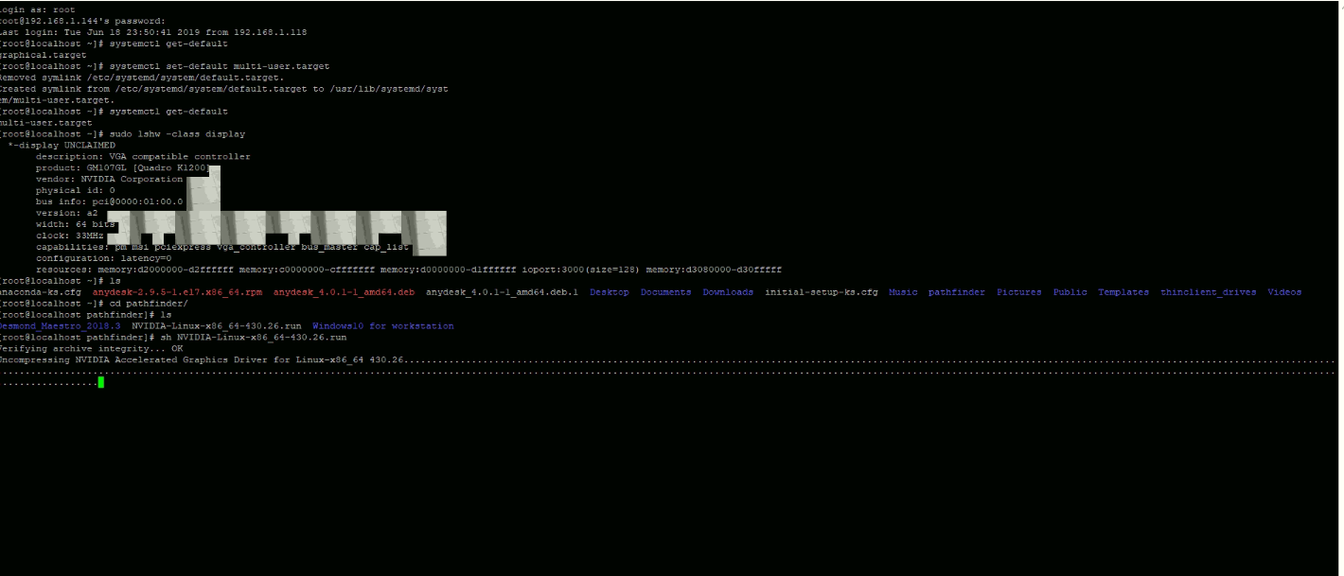
Asking message so clicked on “no”
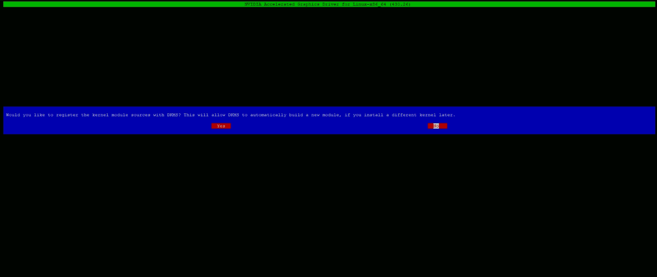

Again asking for option so selected “Install without signature”

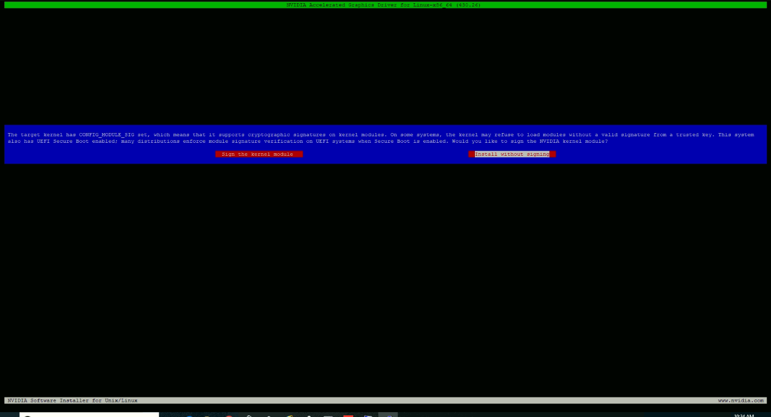
Showing below error after clicking on “Install without signature”
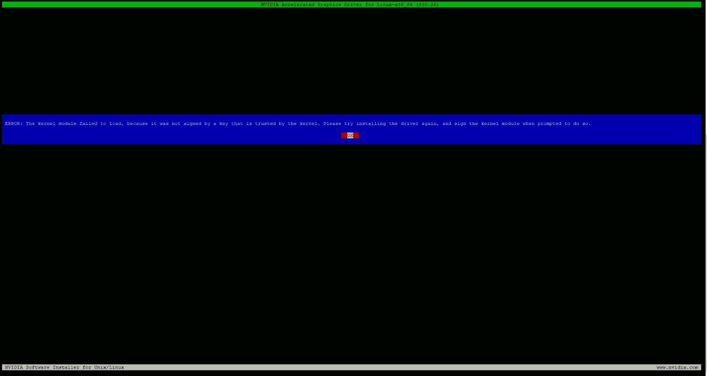

Clicked ok and again system showing below error.
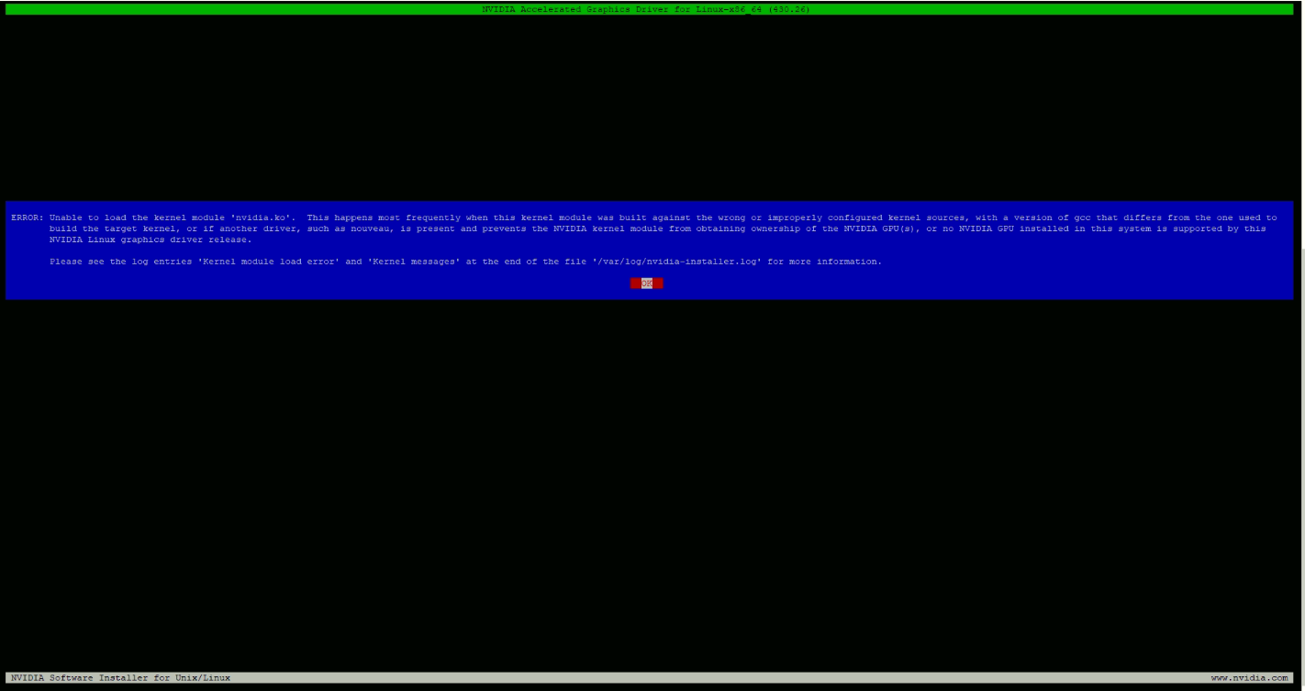
Again prompting for error confirmation so clicked on ok
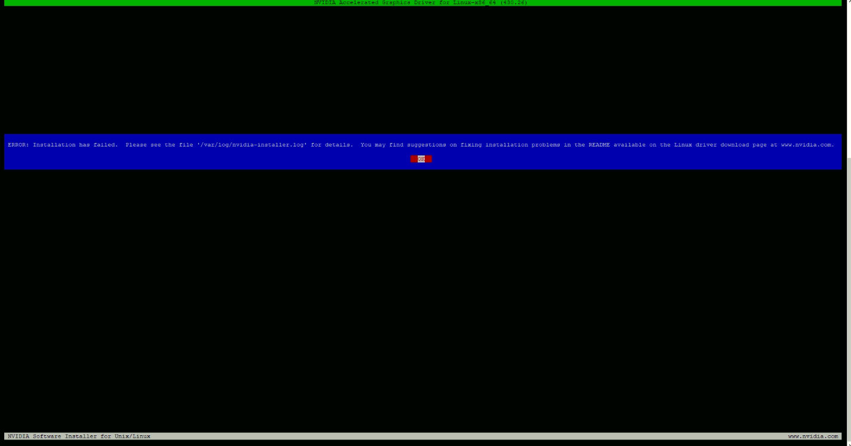

I am attaching installation log file as well with this mail.

