The following content has been modified in the device tree:
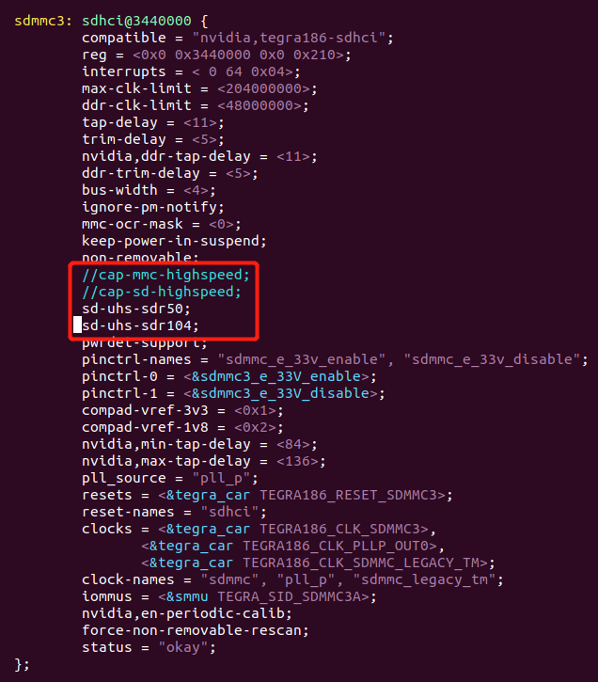
The log information is as follows after powering on and loading the driver：：
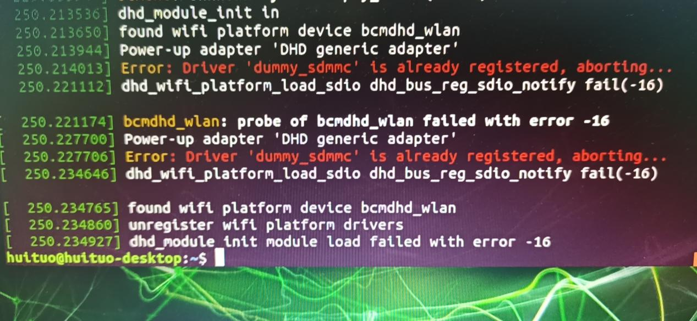
See the dmesg.log

