A B C D E F G H

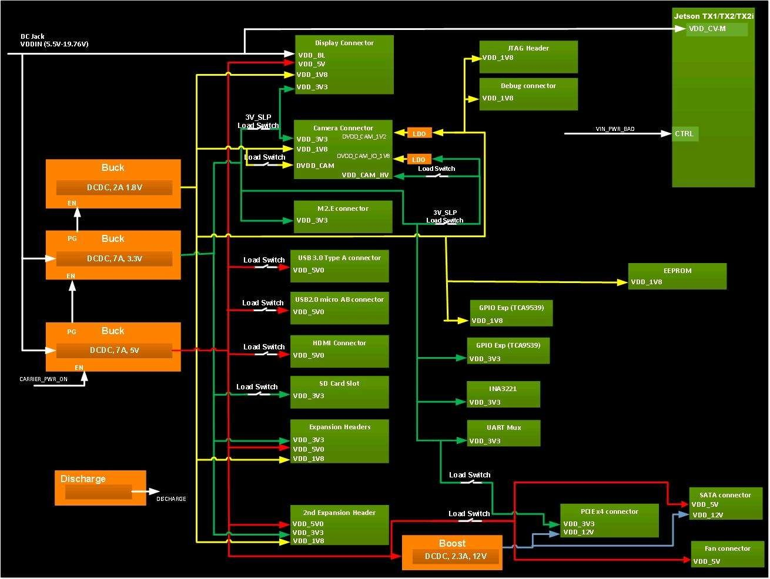
1 1

2 2

3 3

4 4

5 5
Tiiitttllle | <Tiiitttllle>
Siiize  Custtt | Documenttt Numberrr om<Doc> |  |  |  |  | Re v  <Rev
Dattte::: | Frrriiiday,,, Novemberrr 13,,, 2020 | Sheettt | 1 | o fff | 16

Code>

A B C D E F G H

A B C D E F G H

19V
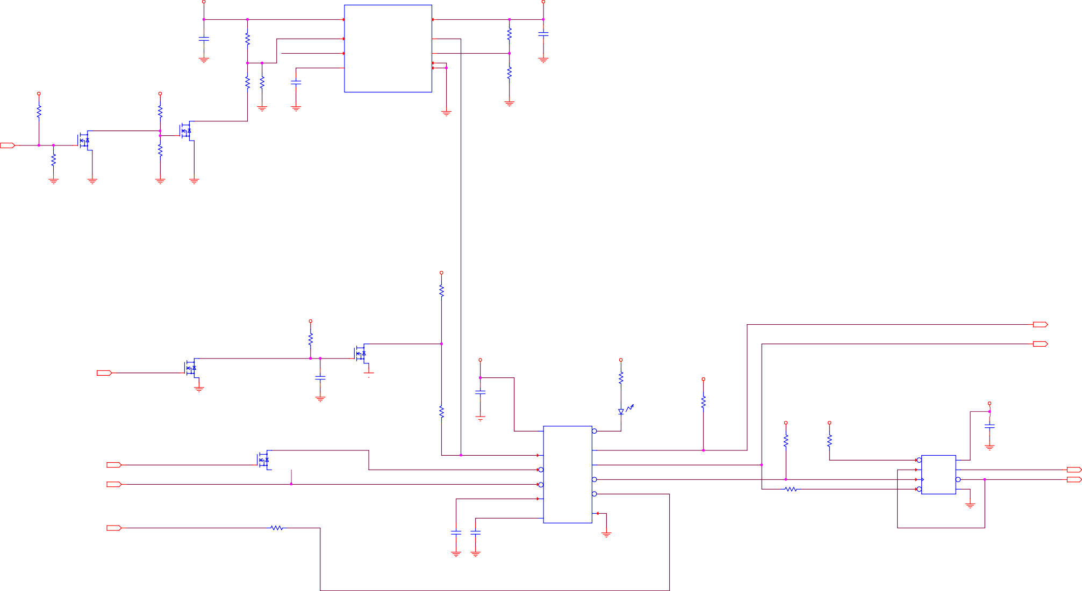VDD_19V_IN

12

OUT

19V

VDD_19V_IN

U52 TPS7A1650DRBR
SON8 COMMON

1/1 TPS7A16x

8 IN

OUT 1

No Stuff Rdiv for Fixed Output
0.2A 0.400
1
5V

5V0_AO
nv_cap

1

19V

VDD_19V_IN
1

R377
10k
nv_res

19V

VDD_19V_IN
1

R390
10k
nv_cap

C223
1uF
25V
10% X7R 603
COMMON

GND
1 2

R338 31.6k
1
1%
402
COMMON
2

nv_res
1

R385 10.7k
1%
402
COMMON
2

nv_res

R376 11.5k
1
1%
402
COMMON
2

5V0_AO_EN

SNN_5V0_AO_NC

5V0_AO_DLY
nv_cap

C230
1nF
50V
5% C0G 402
COMMON

EN

- NC

- DELAY

PG 3

FB_NC 2

GND 4

TPAD 9
5V0_AO_FB

GND
R380
34k
1%
402
NO STUFF
nv_res

nv_res

R381 10.7k
1%
402
NO STUFF
2

GND
1

C235
  - uF
10V
10% X7R 603
COMMON

5%
402
COMMON
2
5%
402
COMMON

1G1D1S

3
D Q59

MOD_PWR_CFG_9V

GND GND

GND

1G1D1S
3

D Q46
BSS138
MOD_PWR_CFG_9V*
BSS138
G SOT23_1G1D1S COMMON
1
2
1

S 2
Enable at 8V or 4.5V Rising

2,11 IN
2
MOD_PWR_CFG_ID

1
1
G

R389
10k
5%
402
COMMON
2
SOT23_1G1D1S COMMON

S 2
R392
10k
5%
402
COMMON
2
2

GND GND GND GND

5V

5V0_AO
1

R379
10k
5%
402
COMMON
2

3
1G1D1S 3
CARRIER_PWR_ON_DLY

5V

5V0_AO
nv_res
1
R288 44.2k
1%
402
COMMON
2

1G1D1S D

1G

3
Q55
BSS138 SOT23_1G1D1S

5V

5V0_AO

5V
5V0_AO
1

ONOFF_CTLR_P1B1OUT MOD_VIN_EN 12

3

OUT

OUT

2,9,11,13,15 IN

CARRIER_PWR_ON

D Q41
BSS138 SOT23_1G1D1S COMMON
1G

S 2
GND
GND

nv_cap

C206 47uF
10V
20% X5R 805
COMMON
COMMON

S 2

GND

nv_res
1
R276
0ohm
0.05 ohm

nv_cap

C233 0.1uF
16V
20% X5R 402
COMMON

U53
SRC0GS22D

LTST-C281KRKT-5A

DS1

30mA
  - V

R391
10k
5%
402
COMMON ONOFF_CTLR_VCCLO_LED
2 2

5V

5V0_AO

R388
1
10k
5%
402
COMMON

5V 5V

5V

5V0_AO

nv_cap

402
COMMON

GND
2
TDFN12 COMMON

1 VCC

VCCLO*
Red 402
7COMMON
1

ONOFF_CTLR_VCCLO_L
5V0_AO

R386
2
1
10k
5%

5V0_AO

R378
1
10k
5%

U42
74LVC1G74

C234 0.1uF
16V
20% X5R 402
COMMON

4

11 IN

MOD_PWR_CFG_ID_L

1G1D1S

1G
3

D Q56
BSS138 SOT23_1G1D1S COMMON

ONOFF_CTLR_PSHOLD

POWER_BTN_2_SR

4 PSHOLD
PBOUT 8
EN/EN* 9
ONOFF_CTLR_PBOUT
MOD_VIN_EN
402
COMMON
2
402
COMMON

MOD_PWR_ON_SET
2
DFN08 COMMON

7 SD*
VCC 8
GND
4

MOD_PWR_ON_STATE

9,16 IN
S 2

POWER_BTN
2 SR*
6 PB*
RST*
10 MOD_PWR_ON_CLK
1R290
nv_res
0ohm2
MOD_PWR_ON_RST
2 D

1 CP

6 RD*
Q 5

Q* 3

GND 4
11

MOD_PWR_ON_STATE_L
11
OUT OUT

ONOFF_CTLR_SR_DLY
5 CSRD
INT* 11
402 0.05 ohm COMMON

2 IN

WAKE_L

1R289
nv_res
0ohm2
C231 0.47uF
nv_cap

ONOFF_CTLR_VREF
nv_cap

C232
1uF

3 VREF
GND 12
GND

402 0.05 ohm COMMON
16V
10% X7R 603
COMMON
6.3V
10% X7R 603
COMMON

GND

GND GND

ONOFF_CTLR_INT

5 5

Tiiitttllle
<Tiiitttllle>

Siiize

Documenttt Numberrr

Re v

Custttom<Doc> <RevCode>

Dattte:::

Frrriiiday,,, Novemberrr 13,,, 2020

Sheettt
10 o fff 16

A B C D E F G H

A B C D E F G H

1 5V
5V0_AO

nv_cap

5V

5V0_AO

1

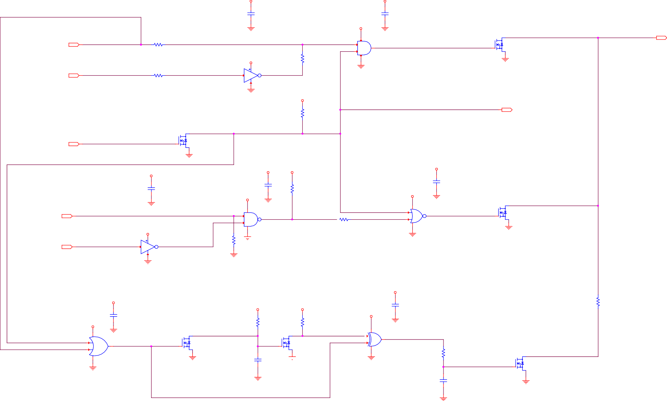
nv_cap

1R277

nv_res
0ohm2

MOD_PWR_ON_STATE_L_R

GND
C196 0.1uF
16V
20% X5R 402
COMMON

5V

5V0_AO

1
5

U41

GND
C190 0.1uF
16V
20% X5R 402
COMMON

1G1D1S

3
D Q50
BSS138

POWER_ON

2,9

OUT

10 IN

MOD_PWR_ON_STATE

402 0.05 ohm COMMON

nv_res

5V
5V0_AO
5

nv_res

R281
1
0ohm
0.05 ohm 402
NO STUFF
2

2

GND
3
SN74LVC1G08

4
SC70-5 COMMON
MOD_PWR_ON_STATE_MASKED
SOT23_1G1D1S COMMON

S 2
1G
GND
ON OFF STATE

10 IN

1R278
0ohm2
2 4
MOD_PWR_ON_STATE_OR_VIN_EN_NOT

402 0.05 ohm COMMON
3
2
GND
U46
SN74LVC1G04 SC70 COMMON

5V

5V0_AO
1

R394
10k
5%
402
COMMON
2

MOD_PWR_CFG_ID_L
10

2

OUT

2,10 IN

MOD_PWR_CFG_ID

1G1D1S D

1G
S

3
Q47
BSS138
SOT23_1G1D1S COMMON

2

5V
5V0_AO

GND

5V
5V0_AO

nv_cap

5V
5V0_AO
1

5V
5V0_AO

nv_cap

3

GND
nv_cap

C195 0.1uF
16V
20% X5R 402
COMMON

5V

5V0_AO

GND

C191 0.1uF
16V
20% X5R 402
COMMON

R280
10k
5%
402
COMMON
2

5V

5V0_AO
5

U40

GND
C189 0.1uF
16V
20% X5R 402
COMMON

1G1D1S

3

3
D Q45

2,9,10,13,15 IN

CARRIER_PWR_ON
U43
1 SN74AUP1G0O0NDOCFKFR_CTLR_PBOUT_MASKED1
5

4

1R28 2
nv_res
0ohm2
- SINGLE_HC1G02
ONOFF_CTLR_PBOUT_MASKED2

4
- SC70
3
BSS138 SOT23_1G1D1S COMMON

S 2
1G
ON/OFF MOMENTARY ALL OTHER PULSES

10 IN

ONOFF_CTLR_PBOUT

5V
5V0_AO
5

2

GND
3

4 ONOFF_CTLR_PBOUT_INV

U45
SN74LVC1G04 SC70 COMMON

nv_res

R4 100k
1
1%
402
COMMON
2

GND
2

3
GND

SC70-5 COMMON
402 0.05 ohm COMMON

GND
COMMON

GND

5V

5V0_AO

5V

nv_cap

nv_res

R284
1

4 5V0_AO

nv_cap

5V

5V0_AO
2

5V
5V0_AO
1
C193 0.1uF
16V
0ohm 4
0.05 ohm 402

5V

5V0_AO
GND

C208 0.1uF
16V
20% X5R 402
COMMON

MOD_PWR_ON_STATE_L_MSK_Q

3
nv_res
R5
1
15k
1%
402
COMMON
2

R9
10k
5%
402
COMMON

MOD_PWR_ON_STATE_LMSK DLY
2

3
5V

5V0_AO

1
5

U44

GND
20% X5R 402
COMMON
COMMON

1G1D1S
5

1
4 1G
D Q51
BSS138 SOT23_1G1D1S
1G1D1S

1G
D Q52
BSS138 SOT23_1G1D1S
U_XOR_2MINOD_PWR_ON_STATE_L_PULSE

4
2 SC70
1
COMMON
3

MOD_PWR_ON_STATE_L
2 U49
SN74LVC1G32DCKR SC70
3
COMMON
COMMON

S 2
GND

nv_cap

C192 47uF
10V
COMMON

S 2

GND
2
GND

R245
10k
5%
402
COMMON

1G1D1S

3
D Q53
BSS138

MOD_PWR_ON_STATE_L_PULSE_F_Q

ON/OFF MOMENTARY INITIAL POWER ON PULSE

GND

MOD_PWR_ON_STATE_L_MSK

GND
20%
X5R 805
COMMON
MOD_PWR_ON_STATE_L_PULSE_F

nv_cap

C194
1uF
16V
20% X5R 402
COMMON
G SOT23_1G1D1S COMMON

S 2
1

GND

5 GND 5

Tiiitttllle

<Tiiitttllle>

Siiize
Documenttt Numberrr
Re v

Custttom<Doc> <RevCode>

Dattte:::

Frrriiiday,,, Novemberrr 13,,, 2020

Sheettt

o fff 16

A B C D E F G H

A B C D E F G H

19V Jack

19V
VDD_19V_CON

19V
1 VDD_19V_CON

19V

9
19V

OUT

1

U533
1 2

1 2

10.0A
6.000

LB16 30ohm
BEAD_0603 COMMON

VDD_19V_IN

10.0A
6.000

1R2004
1206

0ohm2
NO STUFF
12V

VDD_12V_SLP
VDD_19V_IN

10
19V
VDD_MOD

OUT
DC JACK

LB17
30ohm
D13

C179
C177
C178

0.005 ohm

C2228
C2227
C2229
2

BEAD_0603 COMMON

LB15 30ohm
C174 0.1uF

BZX84C24LT1G

C501 4.7uF
10uF
25V

10uF
25V

10uF
25V

LB20
30ohm
10uF
25V

10uF
25V

10uF
25V
OUT

2*1p
3
25V
SOT23
25V
20%
20%
20%
BEAD_0603 NO STUFF
20%
20%
20%

BEAD_0603 COMMON

LB18 30ohm

10%
25.6V
0.225W
1

10%

X5R

X5R

X5R

LB21
30ohm

X5R

X5R

X5R
19V

VDD_MUX

X7R
COMMON
X5R
0603W
0603W
0603W
BEAD_0603 NO STUFF
0603W
0603W
0603W

BEAD_0603 COMMON
603
805
COMMON
COMMON
COMMON

LB22
30ohm
COMMON
COMMON
COMMON

COMMON
COMMON

GND GND

GND
BEAD_0603 NO STUFF

GND

GND

GND

12V
13,15

OUT

GND

PLUG 5.5 0D, 2.5 ID

GND

VDD_12V_SLP

6

OUT

2
1

R501
10k
5%
402
COMMON
2

C237 4.7uF
25V
10% X5R 805
COMMON

MOD_VIN_EN_G

2

3 25V

S 2W
2
-50A
14mohm@10V / 22mohm@4.5V / [ ]@2.5V
1
G
-10A

4 -30V
COMMON

R383
1
10k
5%
402
COMMON

1G1D3S
DFN3X3

PE507BA
D
5 Q30

19V_INPUT

C176 0.47uF

VIN_PWR_BAD_C
1

1R273

10k 2

1G1D1S

VIN_PWR_BAD_CQ 1G

3
D Q31
NTS4001NT1G SOT323_1G1D1S COMMON
VIN_PWR_BAD_L
2,9,13,15

OUT

MOD_VIN_EN
10

1R285

nv_res
0ohm2

MOD_VIN_EN_OPT

1G1D1S

1G
MOD_VIN_EN_D

3
2
D Q43
BSS138 SOT23_1G1D1S
6.000
805 50V
10% X7R
COMMON

R272 100k
1%
402
COMMON
2
402 5% COMMON

COMMON 0.2A
2 1
1
30V SOD523
RB521S30T1G

D31
2

R274
47k
5%
402
COMMON
S 2
30V
0.27A
1500mohm@10V / 1500mohm@4.5V / 1500mohm@2.5V 0.8A
0.33W
20V

IN
402 0.05 ohm COMMON

3
COMMON

S 2
50V
  - A
3500mohm@10V / 3500mohm@4.5V / 3500mohm@2.5V 0.2A
  - W
20V

GND

GND

GND

GND

3

GND

4

1G1D1S

3 VIN_DISCHARGE_G
D

5V
5V0_AO

R382
2 1
10k
5%
402
COMMON

1G1D1S

1G

nv_res

R384
1
221ohm
1%
603
COMMON
2

0V.I5N0_0DISCHARGE_D

3
D Q44
AO3402 SOT23_1G1D1S COMMON

PCB CO-LAYOUT

MAX CURRENT: 8A

LB13 30ohm
BEAD_0603 COMMON

C169
2 1

86..00A0

19V

VDD_MOD

To Compute Module
4

Q42
BSS138
G SOT23_1G1D1S COMMON
1

S 2
50V
S 2
30V
3.4A
52mohm@10V / 65mohm@4.5V / -1000mohm@2.5V 15A
1W
12V

LB12 30ohm
BEAD_0603 COMMON

C186 10uF
25V
20% X5R

C187 10uF
25V
20% X5R

56uF
COMMON 20%
25V@105degC ALE

C77 22uF
35V
20% X5R

C75 10uF
25V
20% X5R

C168 10uF
25V
20% X5R

C166 10uF
25V
20% X5R

C167 0.1uF
50V
10% X7R

0.2A
3500mohm@10V / 3500mohm@4.5V / 3500mohm@2.5V

LB14
30ohm
0603W
0603W
2.8A@105degC,100KHz
0.03ohm
805
0603W
0603W
0603W
603

  - A
  - W
20V

GND
BEAD_0603 COMMON
COMMON
COMMON
SMD_D60
COMMON
COMMON
COMMON
COMMON
COMMON

GND

GND

GND

GND

GND

GND GND

GND

GND

1R1999
1206

0ohm2
NO STUFF

19V

VDD_MUX

To IO board

0.005 ohm

5 5

Tiiitttllle
<Tiiitttllle>

Siiize

Documenttt Numberrr

Re v

Custttom<Doc> <RevCode>

Dattte:::

Frrriiiday,,, Novemberrr 13,,, 2020

Sheettt
- o fff 16

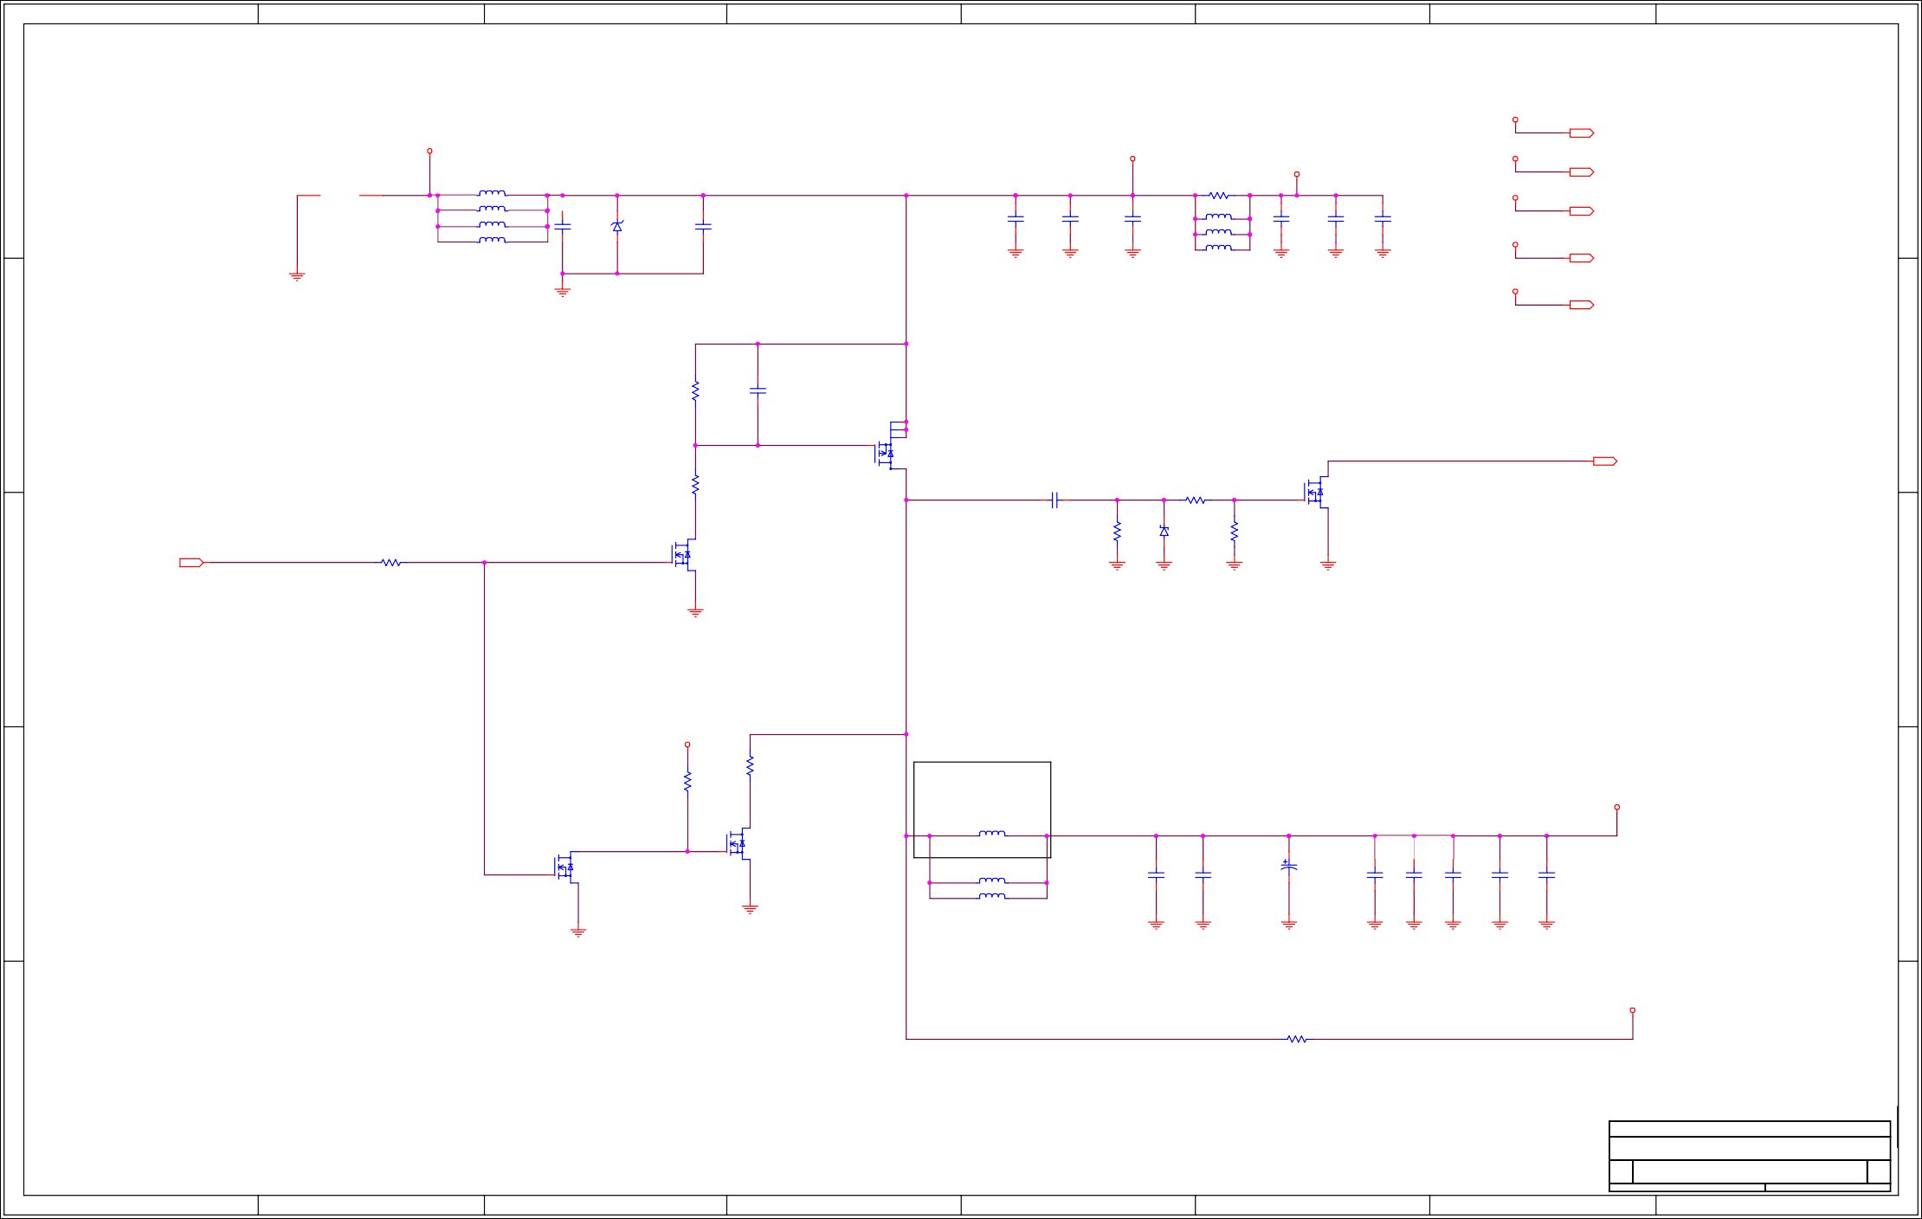
A B C D E F G H

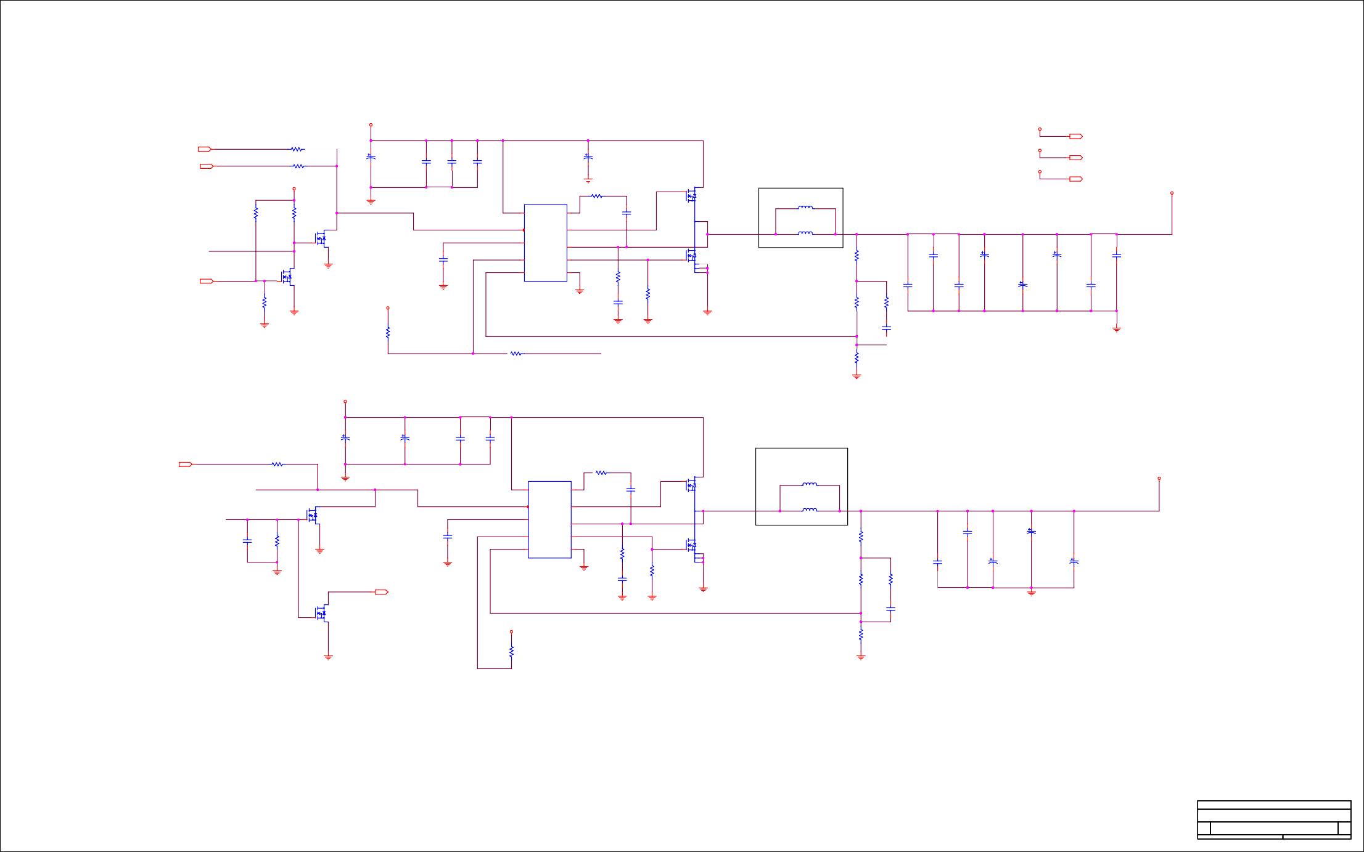
5V & 3V3 SYS POWER SUPPLIES

19V
VDD_MUX

5V
VDD_5V0_IO_SYS

IN 9
5V_SYS_EN
1R2016
402
0ohm2
NC
C172 56uF
C165
0.100
C163
C164
8.0A
C173 56uF
19V
VDD_MUX
5,6,8,14,15 OU T

CARRIER_PWR_ON
0.05 ohm
1R507
0ohm2
COMMON
20%
1
22uF
25V
1uF
50V
1uF
50V
COMMON
20%
1
12,15

V
OU T

IN 2,9..11,15

402

0.05 ohm

5V

COMMON
25V@105degC
ALE 2.8A@105degC,100KHz
2
0.03ohm SMD_D60

10% X5R 1206
COMMON

10% X5R 603
COMMON

10% X5R 603
COMMON
25V@105degC
ALE 2.8A@105degC,100KHz
2
0.03ohm
SMD_D60
VDD_3V3_SYS

14,15

OU T

VDD_5V0_IO_SYS

VIN=4.5V-28 V
U31
TPS53015
0.773V

VBST_IO
GND

1R515

1ohm2

BUCK_BST_IO

D1
G11

2

Q29

PCB CO-LAYOUT
5V
VDD_5V0_IO_SYS

R504
1

R503
1

GND
XSOP10 COMMON
402 5% COMMON

0.400

C504
SiZ918DT-T1-GE3
WPAK_DUAL_COPAD COMMON

L15

1uH

10k
5%
402
COMMON
2
47k
5%
402
COMMON
2
1G1D1S D 6
BUCK_IO_EN
5 VIN
4 EN
VBST 10
DRVH 9
0.400
BUCK_IO_HSDR
1.000
0.1uF
16V
10% X7R 402
COMMON
S1/D2 7
4.000
SMD_9X8 NO STUFF
VDD_5V0_IO_SYS_R
4.000
13.0A
4.000

Q511A

VIN=4.5V-28 V
L16
1uH
13.0A

D_FORCE_OFF_G
AO6800 SOT23_6D_1G1D1S COMMON
S 5
1G
30V
3.4A
-1000mohm@10V / 75mohm@4.5V / 115mohm@2.5V

C171 4.7uF

0.200

BUCK_IO_VREG

3 VREG5

SW 8

BUCK_IO_VSW

BUCK_IO_LSDR

6.0A
SMD_073X066 COMMON

R243
1
10ohm

C148 22uF

C142 220uF
COMMON
1

C144 220uF
COMMON
1

C158 100uF

D_FORCE_OFF_L

1G1D1S D

3G

4
Q501B
AO6800 SOT23_6D_1G1D1S
20A
1.15W
12V

GND

6.3V
10% X5R 603
COMMON
2 PG

1 VFB
DRVL 7

PGND 6

R512
3.3ohm
1
5%
2
1.000
G62
S2 3
4
5

R for test and measurement
1%
603
COMMON
1 2

BUCK_FB_IO_MID

C149
16V
20% X5R 0805LP
COMMON

C154
20%
6.3V@105degC TA-Polymer
2
1.7A@45degC,100KHz
0.045ohm SMD_3528

C143
2 1
20%
6.3V@105degC TA-Polymer
2
1.7A@45degC,100KHz
0.045ohm SMD_3528

C156
6.3V
20% X5R 1206
COMMON

IN
1

R505 1M
5%
402
COMMON
2
COMMON
S 2
30V
  - A
-1000mohm@10V / 75mohm@4.5V / 115mohm@2.5V 20A
1.15W
12V

GND

5V
VDD_5V0_IO_SYS

R509
1

GND

GND

BUCK_IO_SNUB 1.000

GND
603
COMMON

C503 680pF
50V
5% C0G 603
COMMON

GND
2

R514
1
75k
5%
402
COMMON

ROCL

GND

0.400

Vout = Vref * ((Rb1 / Rb2) + 1) Vref = 0.773V

Rb1

R251 121k
1%
402
COMMON
2

R250
1
1k
5%
402
COMMON
BUCK_FB_IO_MID_R
2

C161 150pF
0.1uF
16V
10% X7R 402
COMMON
22uF
16V
20% X5R 0805LP
COMMON
220uF
COMMON 20%
6.3V@105degC TA-Polymer
1.7A@45degC,100KHz
0.045ohm SMD_3528
100uF
6.3V
20% X5R 1206
COMMON

GND
10k
5%
402
COMMON
2

VDD_5V0_IO_SYS_PG

R510

0ohm

Iocl=(((Vin-Vout)*Vout)/2*L*fsw*Vin)+Vtrip/Rdson

3V3_SYS_BUCK_EN

BUCK_IO_FB

Rb2

R256
1
50V
5% C0G 402
COMMON

GND

1 2
402 COMMON

0.05 ohm
22.1k
1%
402
COMMON
2

GND

19V
VDD_MUX

8.0A

IN 9
3V3_SYS_EN
1R2017
402
0ohm2
NC

C125 56uF
COMMON
1
20%
25V@105degC ALE
2
2.8A@105degC,100KHz
0.03ohm SMD_D60

C126 56uF
COMMON
1
20%
25V@105degC ALE
2
2.8A@105degC,100KHz
0.03ohm SMD_D60

C106
1uF
50V
10% X5R 603
COMMON

C107
1uF
50V
10% X5R 603
COMMON

U16
TPS53015

R536

1ohm

BUCK_BST

3.3V

0.05 ohm

3V3_SYS_BUCK_EN

GND
0.773V
XSOP10
NS COMMON
5 VIN

VBST

VBST 10

0.400
1 2
402 5% COMMON
0.400

BUCK_HSDR

C513 0.1uF
16V
10% X7R 402

D1
G11

2

Q23
SiZ918DT-T1-GE3 WPAK_DUAL_COPAD COMMON

PCB CO-LAYOUT

L8 2.2uH
SMD_6X6 NO STUFF

VDD_3V3_SYS_PWR_R

8.0A

VDD_3V3_SYS

4.000

D_FORCE_OFF_G

C502 0.1uF
1
16V
10% X7R
2

R502 1M
5%
402
COMMON
3
D Q503
FDV301N SOT23_1G1D1S COMMON
1G
S 2 1G1D1S
25V
0.22A
-1000mohm@10V / 4000mohm@4.5V / -1000mohm@2.5V 0.5A
0.35W
8V

C120 4.7uF
6.3V
10% X5R 603

0.200

BUCK_VREG
4 EN

3 VREG5

2 PG

1 VFB
DRVH 9

SW 8

DRVL 7

PGND 6

BUCK_VSW

BUCK_LSDR
1.000

R533
2
1
COMMON

8.0A

1.000
S1/D2 7
G62
1
4.000

L7 1uH
SMD_073X066 COMMON

R for test and measurement

R159
1
10ohm
1%
603
COMMON
2

8.0A

C88
1uF
50V
10% X5R 603
COMMON

C76 220uF
COMMON 20%
2 1
6.3V@105degC TA-Polymer
1.7A@45degC,100KHz
4.000

402
COMMON

GND

1G1D1S
GND

3

VIN_PWR_BAD_L
2
2,9,12,15

OU T

GND
COMMON

GND

BUCK_SNUB 1.000

GND
3.3ohm
5%
603
COMMON

C508 680pF
50V
5% C0G 603
COMMON

GND

R535
75k
5%
402
COMMON
S2 3
4
5

GND

Vout = Vref * ((Rb1 / Rb2) + 1) Vref = 0.773V

Rb1
BUCK_FB_MID

R162 71.5k
1
1
1%
402
COMMON
2

R161
1k
5%
402
COMMON
2

BUCK_FB_MID_R

C97
C90 0.1uF
16V
10% X7R 402
COMMON
C85
220uF
1
COMMON 20%
6.3V@105degC TA-Polymer
2
1.7A@45degC,100KHz
0.045ohm SMD_3528

GND
0.045ohm
SMD_3528
C86
220uF
1
COMMON 20%
6.3V@105degC TA-Polymer
2
1.7A@45degC,100KHz
0.045ohm SMD_3528

D Q502
NTS4001NT1G SOT323_1G1D1S COMMON
1G

BUCK_FB
150pF
50V
5% C0G
1

S 2
30V
0.27A
1500mohm@10V / 1500mohm@4.5V / 1500mohm@2.5V 0.8A
0.33W
20V

GND

3.3V
VDD_3V3_SYS

R513
1
10k
5%
402
COMMON
2

Rb2

GND

R166 21.5k
1%
402
COMMON
2
402
COMMON

Tiiitttllle
<Titlellttii >

Siiize
D

Documenttt Numberrr
<Doc>

Re v
<RevCode>

Dattte:::

Frrriiiday,,, Novemberrr 13,,, 2020

Sheettt
13 offf 16

A B C D E F G H

1 1

3.3V

VDD_3V3_SLP

1V8 POWER SUPPLY AND 3V3_SYS

6..8,15
5V
VDD_5V0_IO_SYS

OUT

1.8V

VDD_1V8

5,6,8,13,15

OUT

3.3V

6,8,15

OUT

5V

VDD_5V0_IO_SYS
VDD_3V3_SYS

13,15

OUT

OUT 2,9
2

RESET_OUT_L

R322
1

R120
1

U9 GND

C57 33uF
COMMON
2 1
20%
16V@105degC TA-Polymer
1.291A@45degC,100KHz
0.045ohm SMD_3528

2

C67 0.1uF
402 16V 10% X7R

5V

VDD_5V0_IO_SYS

NS
0ohm
0.05 ohm 402 COMMON
2

0ohm
0.05 ohm 402 COMMON

APW8805
0.8V DFN10 COMMON
2

9
PGOOD

0.400

3
VIN
SYNV18DBC_3_BST
OpenVReg
SYNV18DBC_3_SW

10
EN/FS
NO STUFF

1.8V

VDD_1V8

2 1.8k
NO STUFF 5%

R1251
402 8

2
MODE/BOOT/NC

1V8_EN

SYNV18DBC_3_VCC
1

0.400
VCC

6 L6
SW SW GND GND THERM

1uH

3.0A
1

VDD_1V8_IO

IN 9

R127
C66 0.1uF
C59 0.1uF
SMD_045_041 COMMON

4
7
R124
0.400

100k
1%
402
COMMON
16V
10% X7R 402
COMMON
2
1
16V
10% X7R 402
COMMON
5

11
FB

GND

R123
10ohm
1%
402
COMMON
SYNV18DBC_3_FB2
1
2

C62
C63 220uF
COMMON
1
20%
6.3V@105degC TA-Polymer
2

GND GND GND

3

SYNV18DBC_3_FB

25.5k
1%
402
COMMON
2

R122
0ohm
0.05 ohm 402 COMMON
2

0.1uF
16V
10% X7R 402
1
COMMON
SYNV18DBC_3_FB_C
1.7A@45degC,100KHz
0.045ohm SMD_3528
GND
3

R119
1
20k
1%
402
COMMON
2

GND

3.3V

VDD_3V3_SYS

4 C69

22uF
16V
20% X5R 0805LP
COMMON
1

C70 22uF
16V
20% X5R 0805LP
COMMON
C71 4

22uF
16V
20% X5R 0805LP
COMMON

R129
75k
5%
402
COMMON

3 8V
S 3.5W
2
-50A

GND

GND

GND

IN 2,9

SOC_PWR_REQ

R136

SW_VDD_3V3_SYS_R

D Q21
3
FDV301N SOT23_1G1D1S COMMON
1G
S 2 1G1D1S
1
25V
0.22A

2 4.7k
COMMON
5%

R1311
402

SW_VDD_3V3_SYS_G

C65 10nF
25V
10% X7R
G

4
2

1G1D3S
-1000mohm@10V / 14mohm@4.5V / 19mohm@2.5V
-13A
1
-20V

COMMON DFN3X3
D

AM7321P
5 Q19

1M
5%
402
COMMON

-1000mohm@10V / 4000mohm@4.5V / -1000mohm@2.5V 0.5A
0.35W
8V
2

GND GND
603
COMMON

3.3V

4.0A

3V3_IO_SLP_R

3.000

3.000

3.3V

VDD_3V3_SLP

5 5

Tiiitttllle
<Tiiitttllle>

Siiize

Documenttt Numberrr

Re v

Custttom<Doc> <RevCode>

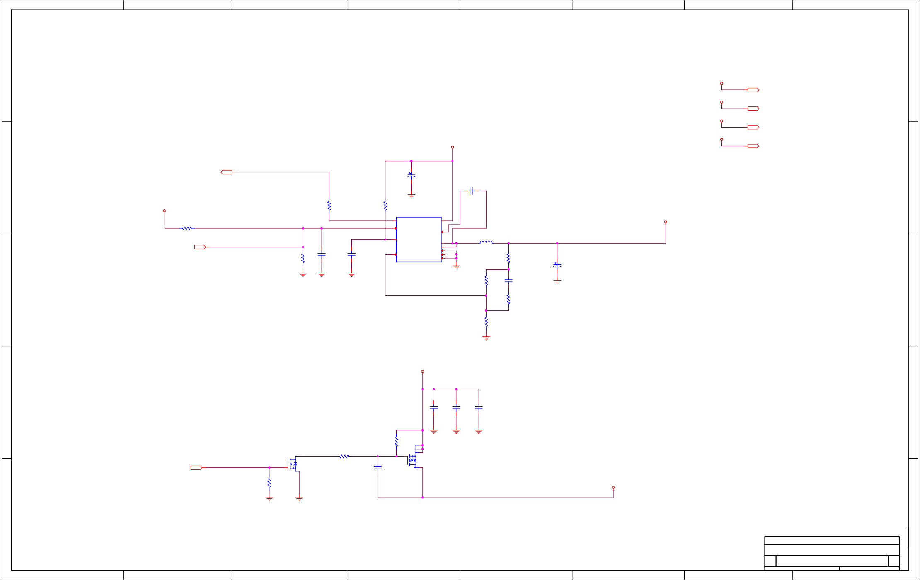

A B C D E F

Dattte:::
G

Frrriiiday,,, Novemberrr 13,,, 2020

Sheettt 14

H

o fff 16

A B C D E F G H

RAIL DISCHARGE

3.3V
VDD_3V3_SLP

6..8,14 OUT
5V
VDD_5V0_IO_SYS

1

19V

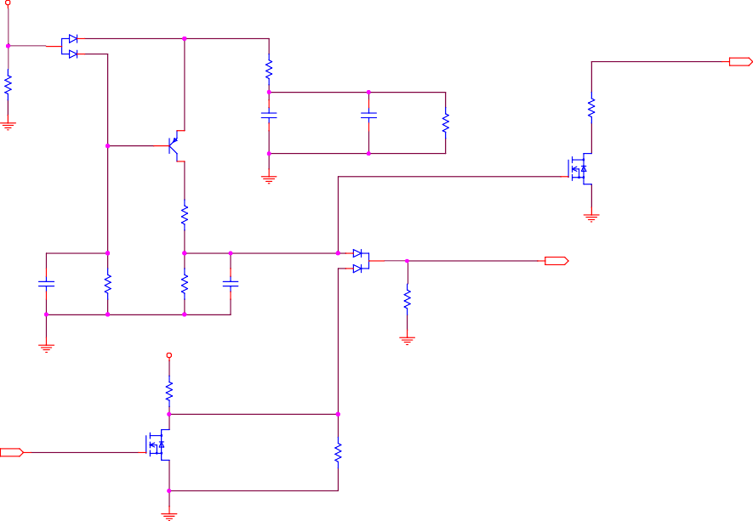V
DD_MUX
D7 BAT54ALT1
30V
0.2A
SOT23
COMMON VDD_MUX_CAP
1
3
2
R98
10k
5%
402
COMMON
R90
0ohm
0.05 ohm 402
COMMOVNDD_MUX_CAP_R
VIN_PWR_BAD_L
2,9,12,13 OUT
E
C53 10uF
25V
2
GND
B
DIS_PNP_B 1 C COMMON
20%
X5R 0603W COMMON
C52 10uF
25V
20% X5R 0603W
COMMON
R88 10M
5%
402
COMMON
R95
0ohm
0.05 ohm 402 COMMON
VIN_PWR_BAD_R_L
SOT23_1B1C1E
MMBT4403
1G1D1S
1B1C1E
3 Q14
DIS_PNP_C
D
1G
S
GND
R93
10k
5%
402
COMMON
2
D5 BAT54CW
30V
0.2A SOT323 COMMON
3
Q13
NTS4001NT1G SOT323_1G1D1S COMMON
2
30V
0.27A
1500mohm@10V / 1500mohm@4.5V / 1500mohm@2.5V 0.8A
0.33W
20V

GND
DISCHARGE_CAT
3
DISCHARGE
6,9
C201 2.2uF
50V
20% X5R 0603W
COMMON
R105
20k
1%
402
COMMON
R94 100k
1%
402
COMMON
C49
1uF
50V
10% X5R 603
COMMON
1
OUT
R63 100k
1%
402
COMMON
19V
VDD_MUX
GND
GND
R77
47k
5%
402
COMMON
DISCHARGE_CAR
1G1D1S
D
IN
CARRIER_PWR_ON
2,9..11,13
1G
3
Q11
NTR4003NT1G SOT23_1G1D1S COMMON
S 2
30V [ ]
-1000mohm@10V / 1500mohm@4.5V / -1000mohm@2.5V 1.7A
0.83W
20V
NS
R78 100k
1%
402
NO STUFF

5,6,8,13,14 OUT
1.8V
VDD_1V8 1
6,8,14
OUT
3.3V
VDD_3V3_SYS
13,14
OUT

19V
1
VDD_MUX
2 1
2
1
1
12,13
OUT

2 2
2
1
2
1
2
1
1
2
2

3 3
2
1
1
2

GND
2

5V

VDD_5V0_IO_SYS

3.3V
VDD_3V3_SYS

1.8V
VDD_1V8

3.3V
VDD_3V3_SLP

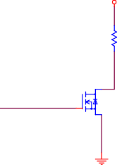
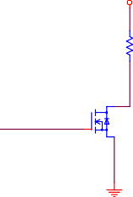
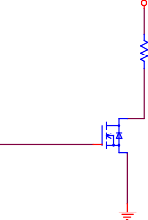
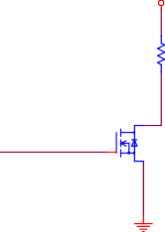
4 4
1
1
1
1

R64
100ohm
5%
603
COMMON
2

R65
47ohm
5%
603
COMMON
2

R75
36ohm
5%
603
COMMON
2

R57
47ohm
5%
603
COMMON
2

0.400

0.400

0.400

0.400

VDD_5V0_DISCHARGE

VDD_3V3_DISCHARGE

VDD_1V8_DISCHARGE

VDD_3V3_SLP_DISCHARGE

DISCHARGE

1G1D1S D

1G
S

3
Q8
NTR4003NT1G SOT23_1G1D1S COMMON

2

DISCHARGE

1G1D1S D

1G
S

3
Q9
NTR4003NT1G SOT23_1G1D1S COMMON

2

DISCHARGE

1G1D1S D

1G
S

3
Q12
NTR4003NT1G SOT23_1G1D1S COMMON

2

DISCHARGE

1G1D1S D

1G
S

3
Q6
NTR4003NT1G SOT23_1G1D1S COMMON

2

30V [ ]
-1000mohm@10V / 1500mohm@4.5V / -1000mohm@2.5V 1.7A
0.83W
20V

30V [ ]
-1000mohm@10V / 1500mohm@4.5V / -1000mohm@2.5V 1.7A
0.83W
20V

30V [ ]
-1000mohm@10V / 1500mohm@4.5V / -1000mohm@2.5V 1.7A
0.83W
20V

30V [ ]
-1000mohm@10V / 1500mohm@4.5V / -1000mohm@2.5V 1.7A
0.83W
20V

GND

GND

GND

GND

5 5

Tiiitttllle
<Tiiitttllle>

Siiize

Documenttt Numberrr

Re v

Custttom<Doc> <RevCode>

Dattte:::

Frrriiiday,,, Novemberrr 13,,, 2020

Sheettt
15 o fff 16

A B C D E F G H

A B C D E F G H

1 1

S4 DTSMW67N
SMD_4
SMD COMMON

3.3V

VDD_3V3_SYS
13..15
OUT

2
2
POWER
2
1
1 R86 0ohm2
POWER_BTN
50OHM_NETCLASS2
402
COMMON
9,10
OUT
50OHM_NETCLASS2
3
D6
ESD9X5.0ST5G SOD923
COMMON
GND
C50
1nF
16V
10% X7R 402
COMMON

4
2 1

GND GND

RECOVERY
2 1

S3 DTSMW67N
SMD_4
SMD COMMON

3
2
1
1 R59 0ohm2
FORCE_RECOVERY_L
402
COMMON
2,9
OUT
3
D4
ESD9X5.0ST5G SOD923
COMMON
GND
C46
1nF
16V
10% X7R 402
COMMON

4

GND

3

GND

VOL DOWN
2 1

S2 DTSMW67N
SMD_4
SMD COMMON

GND GND
2
1
SLEEP_R
1 R34 0ohm2
402
COMMON
SLEEP
2,9
OUT
3
D3
ESD9X5.0ST5G SOD923
COMMON
GND
C35
1nF
16V
10% X7R 402
COMMON

4

4

RESET
2 1

S1 DTSMW67N
SMD_4 SMD
COMMON 4

GND GND
2
1
1 R14 0ohm2
RESET_IN_L
50OHM_NETCLASS2
402
COMMON
2,9
50OHM_NETCLASS2
OUT
3
D2
ESD9X5.0ST5G SOD923
COMMON
GND
C29
1nF
16V
10% X7R 402
COMMON

4

5 5
Tiiitttllle
<Tiiitttllle>
Siiize  Custtt | Documenttt Numberrr om<Doc> |  |  |  |  | Re v  <Rev
Dattte::: | Frrriiiday,,, Novemberrr 13,,, 2020 | Sheettt | 16 | o fff | 16

Code>

A B C D E F G H

