Test Topology
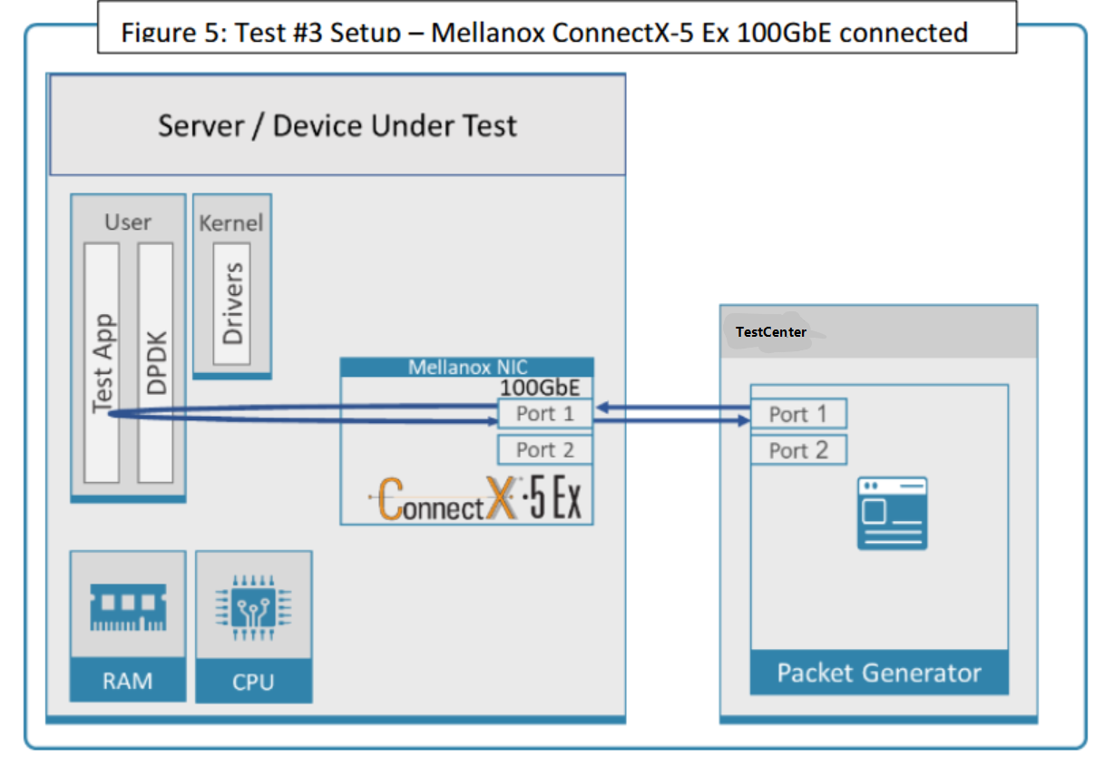

Hardware Infos

TestCenter
model:
SPT-N11U DX2 8-PORT 100GBE QSFP28\DX2-100GO-T8
version 4.86

NIC
model: Mellanox Technologies MT27800 Family [ConnectX-5]
mlxconfig:
[root@vpp1 ~]# mlxconfig -d /dev/mst/mt4119_pciconf0 q

Device #1:
----------

Device type: ConnectX5
Name: MCX516A-CCA_Ax
Description: ConnectX-5 EN network interface card; 100GbE dual-port QSFP28; PCIe3.0 x16; tall bracket; ROHS R6
Device: /dev/mst/mt4119_pciconf0

Configurations: Next Boot

MEMIC_BAR_SIZE 0
MEMIC_SIZE_LIMIT _256KB(1)
HOST_CHAINING_MODE DISABLED(0)
HOST_CHAINING_CACHE_DISABLE False(0)
HOST_CHAINING_DESCRIPTORS Array[0..7]
HOST_CHAINING_TOTAL_BUFFER_SIZE Array[0..7]
FLEX_PARSER_PROFILE_ENABLE 0
FLEX_IPV4_OVER_VXLAN_PORT 0
ROCE_NEXT_PROTOCOL 254
ESWITCH_HAIRPIN_DESCRIPTORS Array[0..7]
ESWITCH_HAIRPIN_TOT_BUFFER_SIZE Array[0..7]
PF_BAR2_SIZE 0
NON_PREFETCHABLE_PF_BAR False(0)
VF_VPD_ENABLE False(0)
PER_PF_NUM_SF False(0)
STRICT_VF_MSIX_NUM False(0)
VF_NODNIC_ENABLE False(0)
NUM_PF_MSIX_VALID True(1)
NUM_OF_VFS 0
PF_BAR2_ENABLE False(0)
SRIOV_EN False(0)
PF_LOG_BAR_SIZE 5
VF_LOG_BAR_SIZE 1
NUM_PF_MSIX 63
NUM_VF_MSIX 11
INT_LOG_MAX_PAYLOAD_SIZE AUTOMATIC(0)
PCIE_CREDIT_TOKEN_TIMEOUT 0
ACCURATE_TX_SCHEDULER True(1)
PARTIAL_RESET_EN True(1)
SW_RECOVERY_ON_ERRORS True(1)
RESET_WITH_HOST_ON_ERRORS True(1)
ADVANCED_POWER_SETTINGS False(0)
CQE_COMPRESSION AGGRESSIVE(1)
IP_OVER_VXLAN_EN False(0)
MKEY_BY_NAME False(0)
ESWITCH_IPV4_TTL_MODIFY_ENABLE False(0)
PRIO_TAG_REQUIRED_EN False(0)
UCTX_EN True(1)
PCI_ATOMIC_MODE PCI_ATOMIC_DISABLED_EXT_ATOMIC_ENABLED(0)
TUNNEL_ECN_COPY_DISABLE False(0)
LRO_LOG_TIMEOUT0 6
LRO_LOG_TIMEOUT1 7
LRO_LOG_TIMEOUT2 8
LRO_LOG_TIMEOUT3 13
LOG_TX_PSN_WINDOW 7
LOG_MAX_OUTSTANDING_WQE 7
ICM_CACHE_MODE DEVICE_DEFAULT(0)
TX_SCHEDULER_BURST 0
ZERO_TOUCH_TUNING_ENABLE False(0)
LOG_DCR_HASH_TABLE_SIZE 11
DCR_LIFO_SIZE 16384
ROCE_CC_PRIO_MASK_P1 8
ROCE_CC_PRIO_MASK_P2 8
CLAMP_TGT_RATE_AFTER_TIME_INC_P1 True(1)
CLAMP_TGT_RATE_P1 False(0)
RPG_TIME_RESET_P1 300
RPG_BYTE_RESET_P1 32767
RPG_THRESHOLD_P1 1
RPG_MAX_RATE_P1 0
RPG_AI_RATE_P1 5
RPG_HAI_RATE_P1 50
RPG_GD_P1 11
RPG_MIN_DEC_FAC_P1 50
RPG_MIN_RATE_P1 1
RATE_TO_SET_ON_FIRST_CNP_P1 0
DCE_TCP_G_P1 1019
DCE_TCP_RTT_P1 1
RATE_REDUCE_MONITOR_PERIOD_P1 4
INITIAL_ALPHA_VALUE_P1 1023
MIN_TIME_BETWEEN_CNPS_P1 0
CNP_802P_PRIO_P1 6
CNP_DSCP_P1 48
CLAMP_TGT_RATE_AFTER_TIME_INC_P2 True(1)
CLAMP_TGT_RATE_P2 False(0)
RPG_TIME_RESET_P2 300
RPG_BYTE_RESET_P2 32767
RPG_THRESHOLD_P2 1
RPG_MAX_RATE_P2 0
RPG_AI_RATE_P2 5
RPG_HAI_RATE_P2 50
RPG_GD_P2 11
RPG_MIN_DEC_FAC_P2 50
RPG_MIN_RATE_P2 1
RATE_TO_SET_ON_FIRST_CNP_P2 0
DCE_TCP_G_P2 1019
DCE_TCP_RTT_P2 1
RATE_REDUCE_MONITOR_PERIOD_P2 4
INITIAL_ALPHA_VALUE_P2 1023
MIN_TIME_BETWEEN_CNPS_P2 0
CNP_802P_PRIO_P2 6
CNP_DSCP_P2 48
LLDP_NB_DCBX_P1 False(0)
LLDP_NB_RX_MODE_P1 OFF(0)
LLDP_NB_TX_MODE_P1 OFF(0)
LLDP_NB_DCBX_P2 False(0)
LLDP_NB_RX_MODE_P2 OFF(0)
LLDP_NB_TX_MODE_P2 OFF(0)
DCBX_IEEE_P1 True(1)
DCBX_CEE_P1 True(1)
DCBX_WILLING_P1 True(1)
DCBX_IEEE_P2 True(1)
DCBX_CEE_P2 True(1)
DCBX_WILLING_P2 True(1)
KEEP_ETH_LINK_UP_P1 True(1)
KEEP_IB_LINK_UP_P1 False(0)
KEEP_LINK_UP_ON_BOOT_P1 False(0)
KEEP_LINK_UP_ON_STANDBY_P1 False(0)
DO_NOT_CLEAR_PORT_STATS_P1 False(0)
AUTO_POWER_SAVE_LINK_DOWN_P1 False(0)
KEEP_ETH_LINK_UP_P2 True(1)
KEEP_IB_LINK_UP_P2 False(0)
KEEP_LINK_UP_ON_BOOT_P2 False(0)
KEEP_LINK_UP_ON_STANDBY_P2 False(0)
DO_NOT_CLEAR_PORT_STATS_P2 False(0)
AUTO_POWER_SAVE_LINK_DOWN_P2 False(0)
NUM_OF_VL_P1 _4_VLs(3)
NUM_OF_TC_P1 _8_TCs(0)
NUM_OF_PFC_P1 8
VL15_BUFFER_SIZE_P1 0
NUM_OF_VL_P2 _4_VLs(3)
NUM_OF_TC_P2 _8_TCs(0)
NUM_OF_PFC_P2 8
VL15_BUFFER_SIZE_P2 0
DUP_MAC_ACTION_P1 LAST_CFG(0)
UNKNOWN_UPLINK_MAC_FLOOD_P1 False(0)
SRIOV_IB_ROUTING_MODE_P1 LID(1)
IB_ROUTING_MODE_P1 LID(1)
DUP_MAC_ACTION_P2 LAST_CFG(0)
UNKNOWN_UPLINK_MAC_FLOOD_P2 False(0)
SRIOV_IB_ROUTING_MODE_P2 LID(1)
IB_ROUTING_MODE_P2 LID(1)
PF_TOTAL_SF 0
PF_SF_BAR_SIZE 0
PCI_WR_ORDERING per_mkey(0)
MULTI_PORT_VHCA_EN False(0)
PORT_OWNER True(1)
ALLOW_RD_COUNTERS True(1)
RENEG_ON_CHANGE True(1)
TRACER_ENABLE True(1)
IP_VER IPv4(0)
BOOT_UNDI_NETWORK_WAIT 30
UEFI_HII_EN True(1)
BOOT_DBG_LOG False(0)
UEFI_LOGS DISABLED(0)
BOOT_VLAN 1
LEGACY_BOOT_PROTOCOL PXE(1)
BOOT_RETRY_CNT NONE(0)
BOOT_INTERRUPT_DIS False(0)
BOOT_LACP_DIS True(1)
BOOT_VLAN_EN False(0)
BOOT_PKEY 0
P2P_ORDERING_MODE DEVICE_DEFAULT(0)
ATS_ENABLED False(0)
DYNAMIC_VF_MSIX_TABLE False(0)
EXP_ROM_UEFI_x86_ENABLE False(0)
EXP_ROM_PXE_ENABLE True(1)
ADVANCED_PCI_SETTINGS False(0)
SAFE_MODE_THRESHOLD 10
SAFE_MODE_ENABLE True(1)

ibv_devinfo:
hca_id: mlx5_0
transport: InfiniBand (0)
fw_ver: 16.30.1004
node_guid: b859:9f03:00c1:f1aa
sys_image_guid: b859:9f03:00c1:f1aa
vendor_id: 0x02c9
vendor_part_id: 4119
hw_ver: 0x0
board_id: MT_0000000012
phys_port_cnt: 1
port: 1
state: PORT_ACTIVE (4)
max_mtu: 4096 (5)
active_mtu: 1024 (3)
sm_lid: 0
port_lid: 0
port_lmc: 0x00
link_layer: Ethernet
pcie info:
lspci -s 3b:00.0 -vvv | grep DevCtl: -C 2
[root@vpp1 ~]# lspci -s 3b:00.0 -vvv | grep DevCtl: -C 2
DevCap: MaxPayload 512 bytes, PhantFunc 0, Latency L0s unlimited, L1 unlimited
ExtTag+ AttnBtn- AttnInd- PwrInd- RBE+ FLReset+ SlotPowerLimit 75.000W
DevCtl: CorrErr- NonFatalErr+ FatalErr+ UnsupReq+
RlxdOrd+ ExtTag+ PhantFunc- AuxPwr- NoSnoop+ FLReset-
MaxPayload 256 bytes, MaxReadReq 512 bytes
[root@vpp1 ~]# lspci -s 3b:00.1 -vvv | grep DevCtl: -C 2
DevCap: MaxPayload 512 bytes, PhantFunc 0, Latency L0s unlimited, L1 unlimited
ExtTag+ AttnBtn- AttnInd- PwrInd- RBE+ FLReset+ SlotPowerLimit 75.000W
DevCtl: CorrErr- NonFatalErr+ FatalErr+ UnsupReq+
RlxdOrd+ ExtTag+ PhantFunc- AuxPwr- NoSnoop+ FLReset-
MaxPayload 256 bytes, MaxReadReq 512 bytes
[root@vpp1 ~]# lspci -s af:00.1 -vvv | grep DevCtl: -C 2
DevCap: MaxPayload 512 bytes, PhantFunc 0, Latency L0s unlimited, L1 unlimited
ExtTag+ AttnBtn- AttnInd- PwrInd- RBE+ FLReset+ SlotPowerLimit 75.000W
DevCtl: CorrErr- NonFatalErr+ FatalErr+ UnsupReq+
RlxdOrd+ ExtTag+ PhantFunc- AuxPwr- NoSnoop+ FLReset-
MaxPayload 256 bytes, MaxReadReq 512 bytes
[root@vpp1 ~]# lspci -s af:00.0 -vvv | grep DevCtl: -C 2
DevCap: MaxPayload 512 bytes, PhantFunc 0, Latency L0s unlimited, L1 unlimited
ExtTag+ AttnBtn- AttnInd- PwrInd- RBE+ FLReset+ SlotPowerLimit 75.000W
DevCtl: CorrErr- NonFatalErr+ FatalErr+ UnsupReq+
RlxdOrd+ ExtTag+ PhantFunc- AuxPwr- NoSnoop+ FLReset-
MaxPayload 256 bytes, MaxReadReq 512 bytes

Server
model:
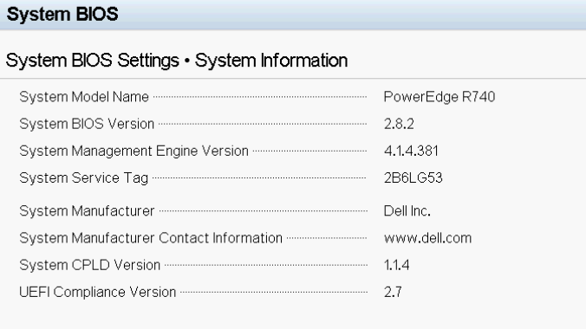

cpu infos
[root@vpp1 ~]# lscpu
Architecture: x86_64
CPU op-mode(s): 32-bit, 64-bit
Byte Order: Little Endian
CPU(s): 40
On-line CPU(s) list: 0-39
Thread(s) per core: 1
Core(s) per socket: 20
Socket(s): 2
NUMA node(s): 2
Vendor ID: GenuineIntel
CPU family: 6
Model: 85
Model name: Intel(R) Xeon(R) Gold 6248 CPU @ 2.50GHz
Stepping: 7
CPU MHz: 3200.147
BogoMIPS: 5000.00
Virtualization: VT-x
L1d cache: 32K
L1i cache: 32K
L2 cache: 1024K
L3 cache: 28160K
NUMA node0 CPU(s): 0,2,4,6,8,10,12,14,16,18,20,22,24,26,28,30,32,34,36,38
NUMA node1 CPU(s): 1,3,5,7,9,11,13,15,17,19,21,23,25,27,29,31,33,35,37,39
Flags: fpu vme de pse tsc msr pae mce cx8 apic sep mtrr pge mca cmov pat pse36 clflush dts acpi mmx fxsr sse sse2 ss ht tm pbe syscall nx pdpe1gb rdtscp lm constant_tsc art arch_perfmon pebs bts rep_good nopl xtopology nonstop_tsc cpuid aperfmperf pni pclmulqdq dtes64 ds_cpl vmx smx est tm2 ssse3 sdbg fma cx16 xtpr pdcm pcid dca sse4_1 sse4_2 x2apic movbe popcnt tsc_deadline_timer aes xsave avx f16c rdrand lahf_lm abm 3dnowprefetch cpuid_fault epb cat_l3 cdp_l3 invpcid_single intel_ppin ssbd mba ibrs ibpb stibp ibrs_enhanced tpr_shadow vnmi flexpriority ept vpid ept_ad fsgsbase tsc_adjust bmi1 hle avx2 smep bmi2 erms invpcid rtm cqm mpx rdt_a avx512f avx512dq rdseed adx smap clflushopt clwb intel_pt avx512cd avx512bw avx512vl xsaveopt xsavec xgetbv1 xsaves cqm_llc cqm_occup_llc cqm_mbm_total cqm_mbm_local dtherm ida arat pln pts pku ospke avx512_vnni md_clear flush_l1d arch_capabilities

memory infos:
[root@vpp1 ~]# dmidecode -t memory
# dmidecode 3.2
Getting SMBIOS data from sysfs.
SMBIOS 3.2 present.

Handle 0x1000, DMI type 16, 23 bytes
Physical Memory Array
Location: System Board Or Motherboard
Use: System Memory
Error Correction Type: Multi-bit ECC
Maximum Capacity: 7680 GB
Error Information Handle: Not Provided
Number Of Devices: 24

Handle 0x1100, DMI type 17, 84 bytes
Memory Device
Array Handle: 0x1000
Error Information Handle: Not Provided
Total Width: 72 bits
Data Width: 64 bits
Size: 32 GB
Form Factor: DIMM
Set: 1
Locator: A1
Bank Locator: Not Specified
Type: DDR4
Type Detail: Synchronous Registered (Buffered)
Speed: 3200 MT/s
Manufacturer: 00AD063200AD
Serial Number: 224A75D0
Asset Tag: 022042D1
Part Number: HMA84GR7DJR4N-XN
Rank: 2
Configured Memory Speed: 2933 MT/s
Minimum Voltage: 1.2 V
Maximum Voltage: 1.2 V
Configured Voltage: 1.2 V
Memory Technology: DRAM
Memory Operating Mode Capability: Volatile memory
Firmware Version: Not Specified
Module Manufacturer ID: Unknown
Module Product ID: Unknown
Memory Subsystem Controller Manufacturer ID: Unknown
Memory Subsystem Controller Product ID: Unknown
Non-Volatile Size: None
Volatile Size: 32 GB
Cache Size: None
Logical Size: None

BIOS Setting
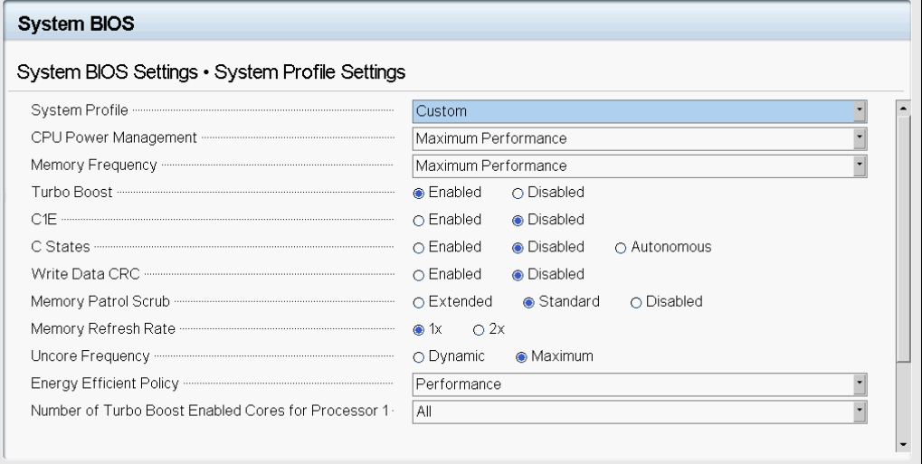
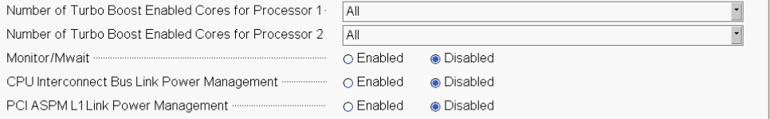
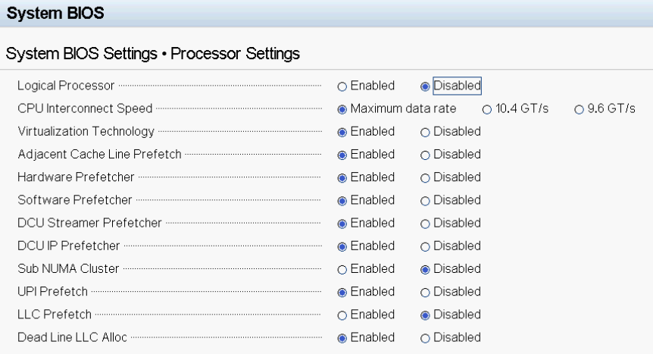
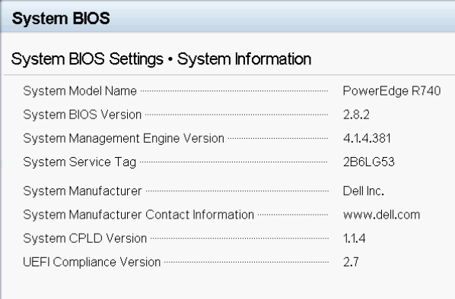

Operating System
[root@vpp1 etc]# uname -a
Linux vpp1 4.19.0-193.1.4.el8_1.bclinux.x86_64 #1 SMP Fri Dec 11 11:33:12 CST 2020 x86_64 x86_64 x86_64 GNU/Linux

[root@vpp1 etc]# cat /etc/os-release
NAME="BigCloud Enterprise Linux"
VERSION="8.1 (Core)"
ID="bclinux"
ID_LIKE="rhel fedora"
VERSION_ID="8.1"
PLATFORM_ID="platform:el8"
PRETTY_NAME="BigCloud Enterprise Linux 8.1 (Core)"
ANSI_COLOR="0;31"
CPE_NAME="cpe:/o:bclinux:bclinux:8"
HOME_URL="https://mirrors.bclinux.org/"
BUG_REPORT_URL="https://bugs.bclinux.org/"

BCLINUX_BUGZILLA_PRODUCT="BigCloud Enterprise Linux 8 (Core)"
BCLINUX_BUGZILLA_PRODUCT_VERSION=8.1
BCLINUX_SUPPORT_PRODUCT="BigCloud Enterprise Linux 8 (Core)"
BCLINUX_SUPPORT_PRODUCT_VERSION=8.1

[root@vpp1 ~]# gcc -v
Using built-in specs.
COLLECT_GCC=gcc
COLLECT_LTO_WRAPPER=/usr/libexec/gcc/x86_64-redhat-linux/8/lto-wrapper
OFFLOAD_TARGET_NAMES=nvptx-none
OFFLOAD_TARGET_DEFAULT=1
Target: x86_64-redhat-linux
Configured with: ../configure --enable-bootstrap --enable-languages=c,c++,fortran,lto --prefix=/usr --mandir=/usr/share/man --infodir=/usr/share/info --with-bugurl=http://bugzilla.redhat.com/bugzilla --enable-shared --enable-threads=posix --enable-checking=release --enable-multilib --with-system-zlib --enable-__cxa_atexit --disable-libunwind-exceptions --enable-gnu-unique-object --enable-linker-build-id --with-gcc-major-version-only --with-linker-hash-style=gnu --enable-plugin --enable-initfini-array --with-isl --disable-libmpx --enable-offload-targets=nvptx-none --without-cuda-driver --enable-gnu-indirect-function --enable-cet --with-tune=generic --with-arch_32=x86-64 --build=x86_64-redhat-linux
Thread model: posix
gcc version 8.4.1 20200928 (Red Hat 8.4.1-1) (GCC)

BOOT Settings
[root@vpp1 ~]# cat /proc/cmdline
BOOT_IMAGE=(hd0,msdos1)/vmlinuz-4.19.0-193.1.4.el8_1.bclinux.x86_64 root=/dev/mapper/bel-root ro crashkernel=auto resume=/dev/mapper/bel-swap rd.lvm.lv=bel/root rd.lvm.lv=bel/swap rhgb quiet iommu=pt intel_iommu=on default_hugepagesz=1G hugepagesz=1G hugepages=300 isolcpus=2-39 intel_idle.max_cstate=0 processor.max_cstate=0 intel_pstate=disable nohz_full=2-39 rcu_nocbs=2-39 rcu_nocb_poll audit=0 nosoflockup

Other optimizations
ethtool -A ens1f0 rx off tx off
ethtool -A ens1f1 rx off tx off
ethtool -A ens4f0 rx off tx off
ethtool -A ens4f1 rx off tx off
sysctl -w vm.zone_reclaim_mode=0
sysctl -w vm.swappiness=0
IRQBALANCE_BANNED_CPUS=2-39 irqbalance --oneshot
systemctl stop irqbalance

[root@vpp1 ~]# lspci | grep Eth
18:00.0 Ethernet controller: Broadcom Inc. and subsidiaries NetXtreme BCM5720 2-port Gigabit Ethernet PCIe
18:00.1 Ethernet controller: Broadcom Inc. and subsidiaries NetXtreme BCM5720 2-port Gigabit Ethernet PCIe
19:00.0 Ethernet controller: Broadcom Inc. and subsidiaries NetXtreme BCM5720 2-port Gigabit Ethernet PCIe
19:00.1 Ethernet controller: Broadcom Inc. and subsidiaries NetXtreme BCM5720 2-port Gigabit Ethernet PCIe
3b:00.0 Ethernet controller: Mellanox Technologies MT27800 Family [ConnectX-5]
3b:00.1 Ethernet controller: Mellanox Technologies MT27800 Family [ConnectX-5]
5e:00.0 Ethernet controller: Intel Corporation Ethernet Controller XXV710 for 25GbE SFP28 (rev 02)
5e:00.1 Ethernet controller: Intel Corporation Ethernet Controller XXV710 for 25GbE SFP28 (rev 02)
af:00.0 Ethernet controller: Mellanox Technologies MT27800 Family [ConnectX-5]
af:00.1 Ethernet controller: Mellanox Technologies MT27800 Family [ConnectX-5]
[root@vpp1 ~]#

[root@vpp1 ~]# setpci -s 3b:00.0 68.w
293e
[root@vpp1 ~]# setpci -s 3b:00.0 68.w=293e
[root@vpp1 ~]# setpci -s 3b:00.1 68.w=293e
[root@vpp1 ~]# setpci -s af:00.0 68.w=293e
[root@vpp1 ~]# setpci -s af:00.1 68.w=293e

[root@vpp1 ~]# free -h
total used free shared buff/cache available
Mem: 376Gi 302Gi 73Gi 13Mi 550Mi 72Gi
Swap: 4.0Gi 0B 4.0Gi

Test Results

Result 1

Testpmd Command Line
./dpdk-testpmd -l 2-34 -n 8 -a 0000:3b:00.0,mprq_en=1,rxqs_min_mprq=1 --file-prefix yyz -- -i --txq=32 --txd=4096 --rxq=32 --rxd=4096 --burst=64 --nb-cores=8
testpmd> set fwd io
testpmd> start

Testpmd Stats

show port stats all:

testpmd> show port stats all

######################## NIC statistics for port 0 ########################
RX-packets: 1266006369 RX-missed: 0 RX-bytes: 374737885224
RX-errors: 0
RX-nombuf: 0
TX-packets: 1090776827 TX-errors: 0 TX-bytes: 322869945232

Throughput (since last show)
Rx-pps: 0 Rx-bps: 0
Tx-pps: 0 Tx-bps: 0
############################################################################

show port xstats all:

testpmd> show port xstats all
###### NIC extended statistics for port 0
rx_good_packets: 2191003466
tx_good_packets: 1887745316
rx_good_bytes: 648537025936
tx_good_bytes: 558772613536
rx_missed_errors: 0
rx_errors: 0
tx_errors: 0
rx_mbuf_allocation_errors: 0
rx_q0_packets: 68014275
rx_q0_bytes: 20132225400
rx_q0_errors: 0
rx_q1_packets: 67883203
rx_q1_bytes: 20093428088
rx_q1_errors: 0
rx_q2_packets: 69010691
rx_q2_bytes: 20427164536
rx_q2_errors: 0
rx_q3_packets: 69587203
rx_q3_bytes: 20597812088
rx_q3_errors: 0
rx_q4_packets: 67640043
rx_q4_bytes: 20021452728
rx_q4_errors: 0
rx_q5_packets: 67835392
rx_q5_bytes: 20079276032
rx_q5_errors: 0
rx_q6_packets: 68109251
rx_q6_bytes: 20160338296
rx_q6_errors: 0
rx_q7_packets: 69249219
rx_q7_bytes: 20497768824
rx_q7_errors: 0
rx_q8_packets: 68864623
rx_q8_bytes: 20383928408
rx_q8_errors: 0
rx_q9_packets: 69539715
rx_q9_bytes: 20583755640
rx_q9_errors: 0
rx_q10_packets: 67736131
rx_q10_bytes: 20049894776
rx_q10_errors: 0
rx_q11_packets: 67510531
rx_q11_bytes: 19983117176
rx_q11_errors: 0
rx_q12_packets: 68713386
rx_q12_bytes: 20339162256
rx_q12_errors: 0
rx_q13_packets: 69049091
rx_q13_bytes: 20438530936
rx_q13_errors: 0
rx_q14_packets: 68124995
rx_q14_bytes: 20164998520
rx_q14_errors: 0
rx_q15_packets: 68634179
rx_q15_bytes: 20315716984
rx_q15_errors: 0
tx_q0_packets: 58990224
tx_q0_bytes: 17461106304
tx_q1_packets: 58990978
tx_q1_bytes: 17461329488
tx_q2_packets: 58991257
tx_q2_bytes: 17461412072
tx_q3_packets: 58993932
tx_q3_bytes: 17462203872
tx_q4_packets: 58990195
tx_q4_bytes: 17461097720
tx_q5_packets: 58992641
tx_q5_bytes: 17461821736
tx_q6_packets: 58989476
tx_q6_bytes: 17460884896
tx_q7_packets: 58992401
tx_q7_bytes: 17461750696
tx_q8_packets: 58992554
tx_q8_bytes: 17461795984
tx_q9_packets: 58994154
tx_q9_bytes: 17462269584
tx_q10_packets: 58992551
tx_q10_bytes: 17461795096
tx_q11_packets: 58989724
tx_q11_bytes: 17460958304
tx_q12_packets: 58994348
tx_q12_bytes: 17462327008
tx_q13_packets: 58991225
tx_q13_bytes: 17461402600
tx_q14_packets: 58990244
tx_q14_bytes: 17461112224
tx_q15_packets: 58993668
tx_q15_bytes: 17462125728
rx_wqe_errors: 0
rx_unicast_packets: 2190969414
rx_unicast_bytes: 648526958088
tx_unicast_packets: 1887586527
tx_unicast_bytes: 558725621168
rx_multicast_packets: 0
rx_multicast_bytes: 0
tx_multicast_packets: 0
tx_multicast_bytes: 0
rx_broadcast_packets: 0
rx_broadcast_bytes: 0
tx_broadcast_packets: 0
tx_broadcast_bytes: 0
tx_phy_packets: 1888006661
rx_phy_packets: 2232745938
rx_phy_crc_errors: 0
tx_phy_bytes: 566301405940
rx_phy_bytes: 669823800300
rx_phy_in_range_len_errors: 0
rx_phy_symbol_errors: 0
rx_phy_discard_packets: 41782554
tx_phy_discard_packets: 0
tx_phy_errors: 0
rx_out_of_buffer: 0
tx_pp_missed_interrupt_errors: 0
tx_pp_rearm_queue_errors: 0
tx_pp_clock_queue_errors: 0
tx_pp_timestamp_past_errors: 0
tx_pp_timestamp_future_errors: 0
tx_pp_jitter: 0
tx_pp_wander: 0
tx_pp_sync_lost: 0

show fwd stats all:

testpmd> show fwd stats all

------- Forward Stats for RX Port= 0/Queue= 0 -> TX Port= 0/Queue= 0 -------
RX-packets: 112087107 TX-packets: 97218318 TX-dropped: 14868789

------- Forward Stats for RX Port= 0/Queue= 1 -> TX Port= 0/Queue= 1 -------
RX-packets: 111871552 TX-packets: 97219566 TX-dropped: 14651986

------- Forward Stats for RX Port= 0/Queue= 2 -> TX Port= 0/Queue= 2 -------
RX-packets: 113731907 TX-packets: 97219332 TX-dropped: 16512575

------- Forward Stats for RX Port= 0/Queue= 3 -> TX Port= 0/Queue= 3 -------
RX-packets: 114679299 TX-packets: 97224016 TX-dropped: 17455283

------- Forward Stats for RX Port= 0/Queue= 4 -> TX Port= 0/Queue= 4 -------
RX-packets: 111470723 TX-packets: 97218162 TX-dropped: 14252561

------- Forward Stats for RX Port= 0/Queue= 5 -> TX Port= 0/Queue= 5 -------
RX-packets: 111791608 TX-packets: 97221777 TX-dropped: 14569778

------- Forward Stats for RX Port= 0/Queue= 6 -> TX Port= 0/Queue= 6 -------
RX-packets: 112245699 TX-packets: 97216859 TX-dropped: 15028840

------- Forward Stats for RX Port= 0/Queue= 7 -> TX Port= 0/Queue= 7 -------
RX-packets: 114127747 TX-packets: 97221765 TX-dropped: 16905982

------- Forward Stats for RX Port= 0/Queue= 8 -> TX Port= 0/Queue= 8 -------
RX-packets: 113490371 TX-packets: 97222271 TX-dropped: 16268100

------- Forward Stats for RX Port= 0/Queue= 9 -> TX Port= 0/Queue= 9 -------
RX-packets: 114601091 TX-packets: 97224515 TX-dropped: 17376576

------- Forward Stats for RX Port= 0/Queue=10 -> TX Port= 0/Queue=10 -------
RX-packets: 111631555 TX-packets: 97222174 TX-dropped: 14409381

------- Forward Stats for RX Port= 0/Queue=11 -> TX Port= 0/Queue=11 -------
RX-packets: 111258883 TX-packets: 97216981 TX-dropped: 14041902

------- Forward Stats for RX Port= 0/Queue=12 -> TX Port= 0/Queue=12 -------
RX-packets: 113241411 TX-packets: 97224499 TX-dropped: 16016912

------- Forward Stats for RX Port= 0/Queue=13 -> TX Port= 0/Queue=13 -------
RX-packets: 113796711 TX-packets: 97219771 TX-dropped: 16576940

------- Forward Stats for RX Port= 0/Queue=14 -> TX Port= 0/Queue=14 -------
RX-packets: 112269635 TX-packets: 97218690 TX-dropped: 15050945

------- Forward Stats for RX Port= 0/Queue=15 -> TX Port= 0/Queue=15 -------
RX-packets: 113107968 TX-packets: 97223421 TX-dropped: 15884547

------- Forward Stats for RX Port= 0/Queue=16 -> TX Port= 0/Queue=16 -------
RX-packets: 114157699 TX-packets: 97222840 TX-dropped: 16934859

------- Forward Stats for RX Port= 0/Queue=17 -> TX Port= 0/Queue=17 -------
RX-packets: 112853571 TX-packets: 97220557 TX-dropped: 15633014

------- Forward Stats for RX Port= 0/Queue=18 -> TX Port= 0/Queue=18 -------
RX-packets: 112142595 TX-packets: 97220321 TX-dropped: 14922274

------- Forward Stats for RX Port= 0/Queue=19 -> TX Port= 0/Queue=19 -------
RX-packets: 111469123 TX-packets: 97219939 TX-dropped: 14249184

------- Forward Stats for RX Port= 0/Queue=20 -> TX Port= 0/Queue=20 -------
RX-packets: 114719043 TX-packets: 97226674 TX-dropped: 17492369

------- Forward Stats for RX Port= 0/Queue=21 -> TX Port= 0/Queue=21 -------
RX-packets: 114078892 TX-packets: 97221748 TX-dropped: 16857144

------- Forward Stats for RX Port= 0/Queue=22 -> TX Port= 0/Queue=22 -------
RX-packets: 112534083 TX-packets: 97219942 TX-dropped: 15314141

------- Forward Stats for RX Port= 0/Queue=23 -> TX Port= 0/Queue=23 -------
RX-packets: 111311043 TX-packets: 97218265 TX-dropped: 14092778

------- Forward Stats for RX Port= 0/Queue=24 -> TX Port= 0/Queue=24 -------
RX-packets: 113430467 TX-packets: 97224391 TX-dropped: 16206076

------- Forward Stats for RX Port= 0/Queue=25 -> TX Port= 0/Queue=25 -------
RX-packets: 111940523 TX-packets: 97221756 TX-dropped: 14718727

------- Forward Stats for RX Port= 0/Queue=26 -> TX Port= 0/Queue=26 -------
RX-packets: 113129027 TX-packets: 97224499 TX-dropped: 15904528

------- Forward Stats for RX Port= 0/Queue=27 -> TX Port= 0/Queue=27 -------
RX-packets: 113616963 TX-packets: 97223218 TX-dropped: 16393745

------- Forward Stats for RX Port= 0/Queue=28 -> TX Port= 0/Queue=28 -------
RX-packets: 110866944 TX-packets: 97216747 TX-dropped: 13650197

------- Forward Stats for RX Port= 0/Queue=29 -> TX Port= 0/Queue=29 -------
RX-packets: 111386473 TX-packets: 97218324 TX-dropped: 14168149

------- Forward Stats for RX Port= 0/Queue=30 -> TX Port= 0/Queue=30 -------
RX-packets: 113924099 TX-packets: 97222176 TX-dropped: 16701923

------- Forward Stats for RX Port= 0/Queue=31 -> TX Port= 0/Queue=31 -------
RX-packets: 113847811 TX-packets: 97221499 TX-dropped: 16626312

---------------------- Forward statistics for port 0 ----------------------
RX-packets: 3610815186 RX-dropped: 0 RX-total: 3610815186
TX-packets: 3111078199 TX-dropped: 499736520 TX-total: 3610814719
----------------------------------------------------------------------------

+++++++++++++++ Accumulated forward statistics for all ports+++++++++++++++
RX-packets: 3610815186 RX-dropped: 0 RX-total: 3610815186
TX-packets: 3111078199 TX-dropped: 499736520 TX-total: 3610814719
++++++++++++++++++++++++++++++++++++++++++++++++++++++++++++++++++++++++++++
testpmd>

TestCenter Result
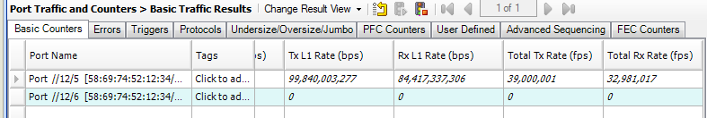

Result 2

Testpmd Command Line
./dpdk-testpmd -l 2,4,6,8,10,12,14,16,18,20,22,24 -n 12 -a 0000:3b:00.0,mprq_en=1,rxqs_min_mprq=1 --file-prefix yyz -- -i --txq=12 --txd=4096 --rxq=12 --rxd=4096 --burst=64 --nb-cores=10

Testpmd Stats

show port stats all:
testpmd> show port stats all

######################## NIC statistics for port 0 ########################
RX-packets: 2474149342 RX-missed: 0 RX-bytes: 658398044664
RX-errors: 0
RX-nombuf: 0
TX-packets: 2222570344 TX-errors: 0 TX-bytes: 583930670728

Throughput (since last show)
Rx-pps: 0 Rx-bps: 0
Tx-pps: 0 Tx-bps: 0
############################################################################

show port xstats all:
testpmd> show port xstats all
###### NIC extended statistics for port 0
rx_good_packets: 3223249572
tx_good_packets: 2881142315
rx_good_bytes: 880131712744
tx_good_bytes: 778867964672
rx_missed_errors: 0
rx_errors: 0
tx_errors: 0
rx_mbuf_allocation_errors: 0
rx_q0_packets: 272658755
rx_q0_bytes: 74450809660
rx_q0_errors: 0
rx_q1_packets: 272647555
rx_q1_bytes: 74447493988
rx_q1_errors: 0
rx_q2_packets: 265858371
rx_q2_bytes: 72593188244
rx_q2_errors: 0
rx_q3_packets: 267179843
rx_q3_bytes: 72954763716
rx_q3_errors: 0
rx_q4_packets: 271212803
rx_q4_bytes: 74059782460
rx_q4_errors: 0
rx_q5_packets: 272456835
rx_q5_bytes: 74398435456
rx_q5_errors: 0
rx_q6_packets: 271346051
rx_q6_bytes: 74091826920
rx_q6_errors: 0
rx_q7_packets: 272733763
rx_q7_bytes: 74473010376
rx_q7_errors: 0
rx_q8_packets: 262608579
rx_q8_bytes: 71705198760
rx_q8_errors: 0
rx_q9_packets: 259774019
rx_q9_bytes: 70932723596
rx_q9_errors: 0
rx_q10_packets: 268213059
rx_q10_bytes: 73238414484
rx_q10_errors: 0
rx_q11_packets: 266559939
rx_q11_bytes: 72786065084
rx_q11_errors: 0
tx_q0_packets: 240486375
tx_q0_bytes: 64927785180
tx_q1_packets: 240490849
tx_q1_bytes: 64929109012
tx_q2_packets: 239770309
tx_q2_bytes: 64871121892
tx_q3_packets: 239894136
tx_q3_bytes: 64878194444
tx_q4_packets: 240296885
tx_q4_bytes: 64908670732
tx_q5_packets: 240449751
tx_q5_bytes: 64924338592
tx_q6_packets: 240330842
tx_q6_bytes: 64911325056
tx_q7_packets: 240479176
tx_q7_bytes: 64925652624
tx_q8_packets: 239573618
tx_q8_bytes: 64886850304
tx_q9_packets: 239246415
tx_q9_bytes: 64856552812
tx_q10_packets: 240157201
tx_q10_bytes: 64933880516
tx_q11_packets: 239966758
tx_q11_bytes: 64914483508
rx_wqe_errors: 0
rx_unicast_packets: 3223214746
rx_unicast_bytes: 880121415200
tx_unicast_packets: 2881062975
tx_unicast_bytes: 778844488912
rx_multicast_packets: 0
rx_multicast_bytes: 0
tx_multicast_packets: 0
tx_multicast_bytes: 0
rx_broadcast_packets: 0
rx_broadcast_bytes: 0
tx_broadcast_packets: 0
tx_broadcast_bytes: 0
tx_phy_packets: 2881533776
rx_phy_packets: 3262951084
rx_phy_crc_errors: 0
tx_phy_bytes: 790397408200
rx_phy_bytes: 904935183832
rx_phy_in_range_len_errors: 0
rx_phy_symbol_errors: 0
rx_phy_discard_packets: 39742303
tx_phy_discard_packets: 0
tx_phy_errors: 0
rx_out_of_buffer: 0
tx_pp_missed_interrupt_errors: 0
tx_pp_rearm_queue_errors: 0
tx_pp_clock_queue_errors: 0
tx_pp_timestamp_past_errors: 0
tx_pp_timestamp_future_errors: 0
tx_pp_jitter: 0
tx_pp_wander: 0
tx_pp_sync_lost: 0

show fwd stats all:
testpmd> show fwd stats all

------- Forward Stats for RX Port= 0/Queue= 0 -> TX Port= 0/Queue= 0 -------
RX-packets: 377856131 TX-packets: 331598198 TX-dropped: 46257933

------- Forward Stats for RX Port= 0/Queue= 1 -> TX Port= 0/Queue= 1 -------
RX-packets: 377838595 TX-packets: 331603946 TX-dropped: 46234649

------- Forward Stats for RX Port= 0/Queue= 2 -> TX Port= 0/Queue= 2 -------
RX-packets: 368429507 TX-packets: 330853332 TX-dropped: 37576175

------- Forward Stats for RX Port= 0/Queue= 3 -> TX Port= 0/Queue= 3 -------
RX-packets: 370262275 TX-packets: 330977730 TX-dropped: 39284545

------- Forward Stats for RX Port= 0/Queue= 4 -> TX Port= 0/Queue= 4 -------
RX-packets: 375872067 TX-packets: 331390882 TX-dropped: 44481185

------- Forward Stats for RX Port= 0/Queue= 5 -> TX Port= 0/Queue= 5 -------
RX-packets: 377593411 TX-packets: 331558968 TX-dropped: 46034443

------- Forward Stats for RX Port= 0/Queue= 6 -> TX Port= 0/Queue= 6 -------
RX-packets: 376032195 TX-packets: 331424449 TX-dropped: 44607746

------- Forward Stats for RX Port= 0/Queue= 7 -> TX Port= 0/Queue= 7 -------
RX-packets: 377969088 TX-packets: 331587747 TX-dropped: 46381280

------- Forward Stats for RX Port= 0/Queue= 8 -> TX Port= 0/Queue= 8 -------
RX-packets: 363921795 TX-packets: 330711510 TX-dropped: 33210285

------- Forward Stats for RX Port= 0/Queue= 9 -> TX Port= 0/Queue= 9 -------
RX-packets: 360000643 TX-packets: 330363869 TX-dropped: 29636774

------- Forward Stats for RX Port= 0/Queue=10 -> TX Port= 0/Queue=10 -------
RX-packets: 371703171 TX-packets: 331312309 TX-dropped: 40390862

------- Forward Stats for RX Port= 0/Queue=11 -> TX Port= 0/Queue=11 -------
RX-packets: 369406147 TX-packets: 331111184 TX-dropped: 38294963

---------------------- Forward statistics for port 0 ----------------------
RX-packets: 4466886113 RX-dropped: 0 RX-total: 4466886113
TX-packets: 3974495145 TX-dropped: 492390840 TX-total: 4466885985
----------------------------------------------------------------------------

+++++++++++++++ Accumulated forward statistics for all ports+++++++++++++++
RX-packets: 4466886113 RX-dropped: 0 RX-total: 4466886113
TX-packets: 3974495145 TX-dropped: 492390840 TX-total: 4466885985
++++++++++++++++++++++++++++++++++++++++++++++++++++++++++++++++++++++++++++
testpmd>

TestCenter Result
