- Ethernet Cable Connected

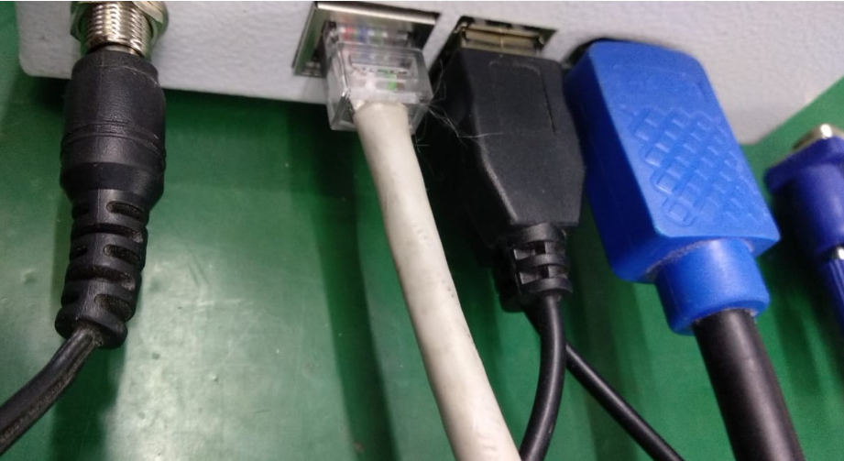
- Ethernet Connectivity – Not Connected/Detected
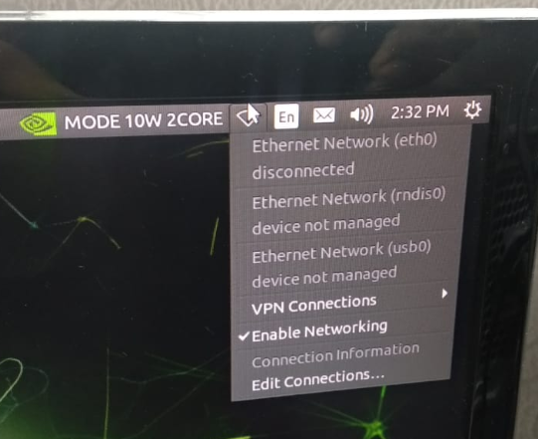

3.IF Config result for Ethernet

