- Detected SOM (With Ethernet issue) with same carrier board.
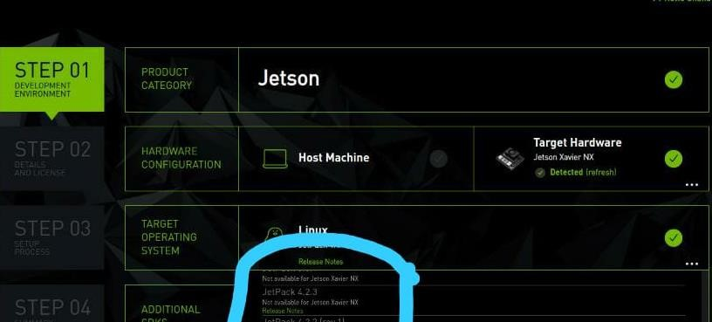
- Connection of power and USB cable.
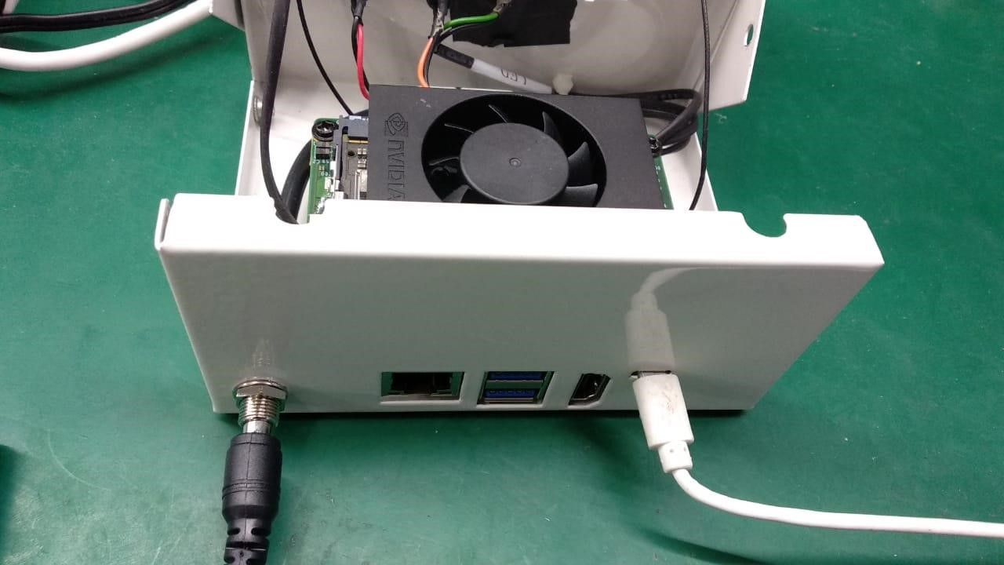
- SOM connection and power on indication.
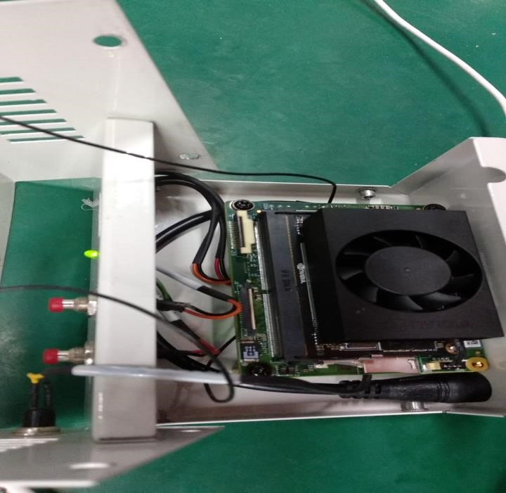
4.USB connection on PC.
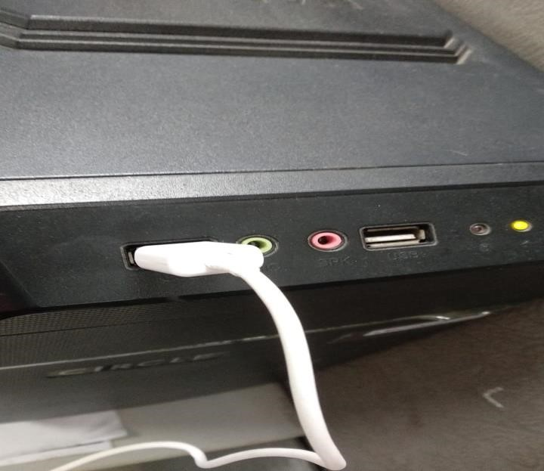
- SDK image with board not detected.
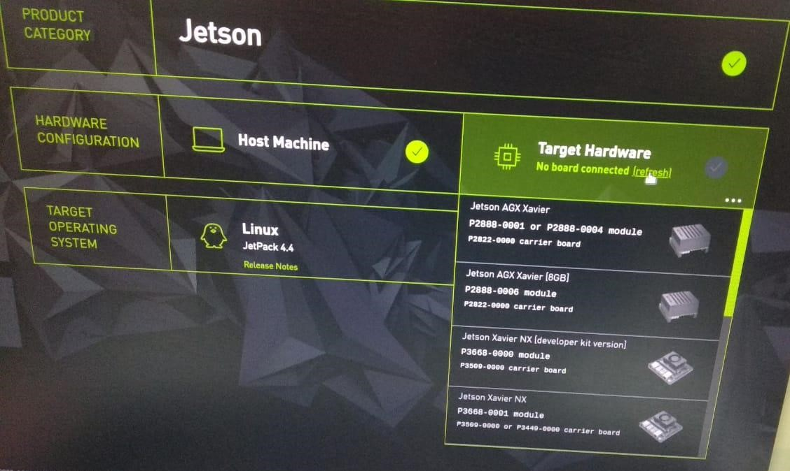
- SDK image with manual selected board even the board was not detected.
