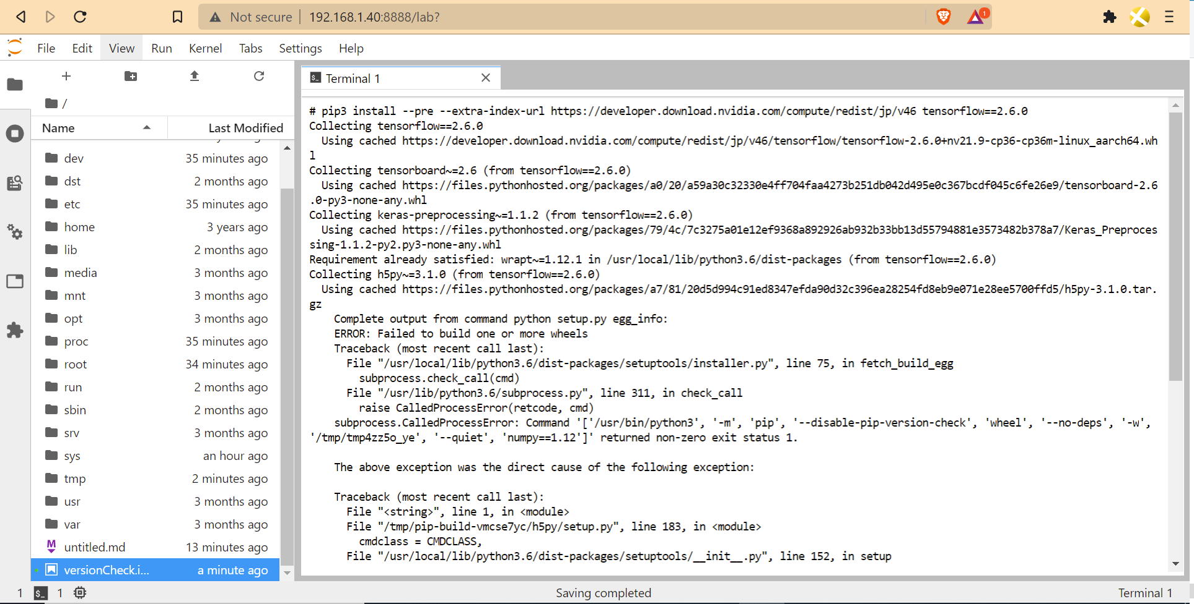
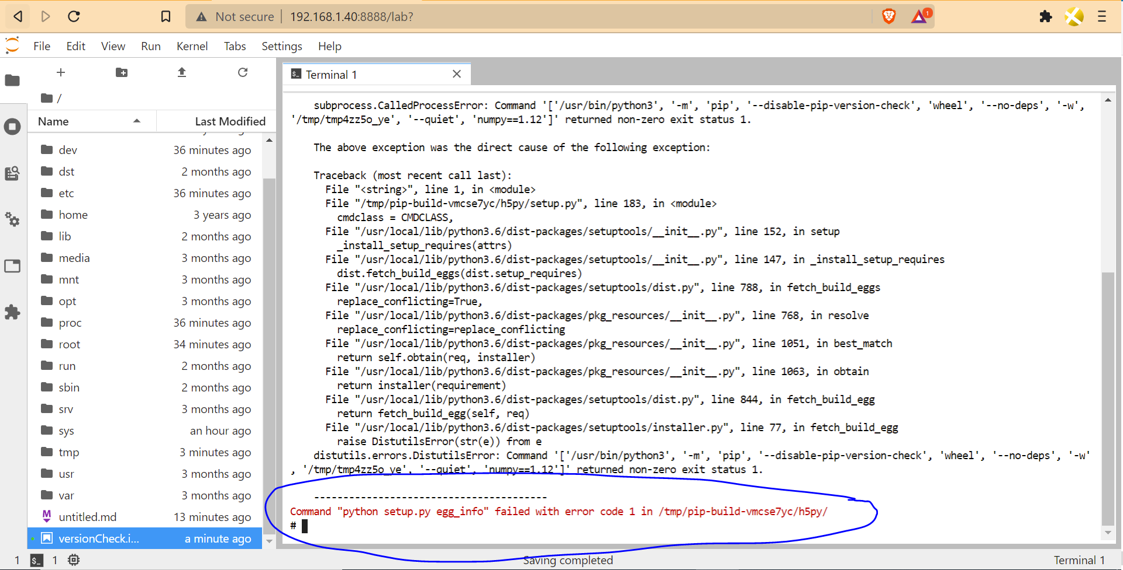
Detailed terminal
# pip3 install --pre --extra-index-url https://developer.download.nvidia.com/compute/redist/jp/v46 tensorflow==2.6.0
Collecting tensorflow==2.6.0
Using cached https://developer.download.nvidia.com/compute/redist/jp/v46/tensorflow/tensorflow-2.6.0+nv21.9-cp36-cp36m-linux_aarch64.whl
Collecting tensorboard~=2.6 (from tensorflow==2.6.0)
Using cached https://files.pythonhosted.org/packages/a0/20/a59a30c32330e4ff704faa4273b251db042d495e0c367bcdf045c6fe26e9/tensorboard-2.6.0-py3-none-any.whl
Collecting keras-preprocessing~=1.1.2 (from tensorflow==2.6.0)
Using cached https://files.pythonhosted.org/packages/79/4c/7c3275a01e12ef9368a892926ab932b33bb13d55794881e3573482b378a7/Keras_Preprocessing-1.1.2-py2.py3-none-any.whl
Requirement already satisfied: wrapt~=1.12.1 in /usr/local/lib/python3.6/dist-packages (from tensorflow==2.6.0)
Collecting h5py~=3.1.0 (from tensorflow==2.6.0)
Using cached https://files.pythonhosted.org/packages/a7/81/20d5d994c91ed8347efda90d32c396ea28254fd8eb9e071e28ee5700ffd5/h5py-3.1.0.tar.gz
Complete output from command python setup.py egg_info:
ERROR: Failed to build one or more wheels
Traceback (most recent call last):
File "/usr/local/lib/python3.6/dist-packages/setuptools/installer.py", line 75, in fetch_build_egg
subprocess.check_call(cmd)
File "/usr/lib/python3.6/subprocess.py", line 311, in check_call
raise CalledProcessError(retcode, cmd)
subprocess.CalledProcessError: Command '['/usr/bin/python3', '-m', 'pip', '--disable-pip-version-check', 'wheel', '--no-deps', '-w', '/tmp/tmp4zz5o_ye', '--quiet', 'numpy==1.12']' returned non-zero exit status 1.

The above exception was the direct cause of the following exception:

Traceback (most recent call last):
File "<string>", line 1, in <module>
File "/tmp/pip-build-vmcse7yc/h5py/setup.py", line 183, in <module>
cmdclass = CMDCLASS,
File "/usr/local/lib/python3.6/dist-packages/setuptools/__init__.py", line 152, in setup
_install_setup_requires(attrs)
File "/usr/local/lib/python3.6/dist-packages/setuptools/__init__.py", line 147, in _install_setup_requires
dist.fetch_build_eggs(dist.setup_requires)
File "/usr/local/lib/python3.6/dist-packages/setuptools/dist.py", line 788, in fetch_build_eggs
replace_conflicting=True,
File "/usr/local/lib/python3.6/dist-packages/pkg_resources/__init__.py", line 768, in resolve
replace_conflicting=replace_conflicting
File "/usr/local/lib/python3.6/dist-packages/pkg_resources/__init__.py", line 1051, in best_match
return self.obtain(req, installer)
File "/usr/local/lib/python3.6/dist-packages/pkg_resources/__init__.py", line 1063, in obtain
return installer(requirement)
File "/usr/local/lib/python3.6/dist-packages/setuptools/dist.py", line 844, in fetch_build_egg
return fetch_build_egg(self, req)
File "/usr/local/lib/python3.6/dist-packages/setuptools/installer.py", line 77, in fetch_build_egg
raise DistutilsError(str(e)) from e
distutils.errors.DistutilsError: Command '['/usr/bin/python3', '-m', 'pip', '--disable-pip-version-check', 'wheel', '--no-deps', '-w', '/tmp/tmp4zz5o_ye', '--quiet', 'numpy==1.12']' returned non-zero exit status 1.

----------------------------------------
Command "python setup.py egg_info" failed with error code 1 in /tmp/pip-build-vmcse7yc/h5py/

