Orin NX kernel customisation
Modifying the Kernel and recompiling:
REF: https://medium.com/@haoye94/editing-device-tree-and-compiling-kernel-for-nvidia-jetson-xavier-nx-11a1df20939c

Procedure to change HDMI to DP as default display on OrinNX
(REF: https://forums.developer.nvidia.com/t/orin-nx-dp-enable-fail/246019)

Switch default display from HDMI to DP

The default display configuration for Orin is HDMI. To change display to DP the pinmux needs to be changed and the kernel recompiled.

Patch1: remove HDMI hotplug

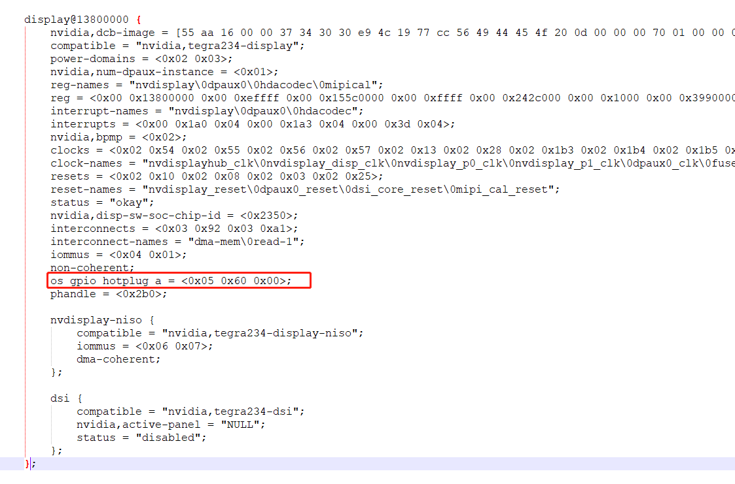
cd kernel/dtb

sudo dtc -I dtb -O dts -o output.dts tegra234-p3767-0000-p3509-a02.dtb
sudo nano output.dts

Delete this line:

os_gpio_hotplug_a = <0x5 0x60 0x0>;

recompile to dtb

sudo dtc -I dts -O dtb -o tegra234-p3767-0000-p3509-a02.dtb output.dts

Patch 2: swap HDMI to DP

sudo grep -rnwl -e 'tegra234-dcb-p3767-0000-hdmi.dtsi’
sudo grep -rnwl -e 'tegra234-dcb-p3767-0000-dp.dtsi’

This file “tegra234-dcb-p3767-0000-hdmi.dtsi” is referenced by this file “tegra234-p3767-0000-p3509-a02.dts.

Sudo nano hardware/nvidia/platform/t23x/p3768/kernel-dts/tegra234-p3767-0000-p3509-a02.dts

change this line
#include "tegra234-dcb-p3767-0000-hdmi.dtsi"

for this line
#include "tegra234-dcb-p3767-0000-dp.dtsi"

The dcb image in that “dp” dtsi is for displayport… so you just need to swap the file name from hdmi to dp and you don’t need to update dcb image manually.

Patch 3: recompile pinmux (refer to section on Pinmux Changes)

The pinmux requires full flash too. Regenerate a new pinmux file with DP selected (not HDMI) and update pinmux in sources. The pinmux specifies different pinout and signals for DP.

Download the pinmux spreadsheet for 35.2.1:

https://developer.nvidia.com/downloads/jetson-orin-nx-and-orin-nano-series-pinmux-config-template

sudo chmod +x /home/z/Downloads/Jetson_Orin_NX_series_and_Orin_Nano_series_Pinmux_Config_Template.xlsm

sudo cp /home/z/Downloads/Jetson_Orin_NX_series_and_Orin_Nano_series_Pinmux_Config_Template.xlsm /home/z/SSD/L4T-35.2.1-Orin/

open the spreadsheet with Microsoft Excel on Windows 10 platform, enable editing and accept the security warning .
Select the A03 DP Spreadsheet and generate the three .dti files

copy those files to the sources directoriy on the linux host machine (cd /home/z/SSD/L4T-35.2.1-Orin/).

Orin-jetson_orin_nx_series_+dp a03-gpio-default.dtsi
Orin-jetson_orin_nx_series_+dp a03-padvoltage-default.dtsi
Orin-jetson_orin_nx_series_+dp a03-pinmux.dtsi

These are the original file names in the default sources file system (/home/z/SSD/L4T-35.2.1-Orin/Linux_for_Tegra/bootloader/t186ref/BCT/)

tegra234-mb1-bct-pinmux-p3767-hdmi-a03.dtsi
tegra234-mb1-bct-padvoltage-p3767-hdmi-a03.dtsi

(home/z/SSD/L4T-35.2.1-Orin/Linux_for_Tegra/bootloader/)
tegra234-mb1-bct-gpio-p3767-hdmi-a03.dtsi

Rename the files to match the existing file name convention so there is no naming convention error when recompiling.

Copy the pinmux.dtsi file to the <l4t_top>/bootloader/t186ref/BCT/ directory, and copy the gpio.dtsi file to the <l4t_top>/bootloader/ directory. You do not need to copy the padvoltage.dtsi file.

Step 1, change windows file names to linux compatible file names:

cd /home/z/SSD/L4T-35.2.1-Orin/

sudo mv 'Orin-jetson_orin_nx_series_+dp a03-pinmux.dtsi' Orin-jetson_orin_nx_series_+dp_a03-pinmux.dtsi
sudo mv 'Orin-jetson_orin_nx_series_+dp a03-padvoltage-default.dtsi' Orin-jetson_orin_nx_series_+dp_a03-padvoltage-default.dtsi
sudo mv 'Orin-jetson_orin_nx_series_+dp a03-gpio-default.dtsi' Orin-jetson_orin_nx_series_+dp_a03-gpio-default.dtsi

step 2, change file names to match existing pinmux file names in dtsi folder:

ls | grep pinmux => tegra234-mb1-bct-pinmux-p3767-hdmi-a03.dtsi
ls | grep padvoltage => tegra234-mb1-bct-padvoltage-p3767-hdmi-a03.dtsi
ls | grep gpio => tegra234-mb1-bct-gpio-p3767-hdmi-a03.dtsi

step 3, move the new pinmux file to BCT directory with new dp name to match old names,

cd ~/SSD/L4T-35.2.1-Orin

sudo mv Orin-jetson_orin_nx_series_+dp_a03-pinmux.dtsi tegra234-mb1-bct-pinmux-p3767-dp-a03.dtsi

sudo cp tegra234-mb1-bct-pinmux-p3767-dp-a03.dtsi /home/z/SSD/L4T-35.2.1-Orin/Linux_for_Tegra/bootloader/t186ref/BCT/

step 4, move the new gpio file to bootloader directory with new dp name to match old name,

sudo mv Orin-jetson_orin_nx_series_+dp_a03-gpio-default.dtsi tegra234-mb1-bct-gpio-p3767-dp-a03.dtsi

sudo cp tegra234-mb1-bct-gpio-p3767-dp-a03.dtsi /home/z/SSD/L4T-35.2.1-Orin/Linux_for_Tegra/bootloader/

Edit the conf file in /Linux_for_Tegra/p3509-a02+p3767-0000.conf for displayport file names

PINMUX_CONFIG="tegra234-mb1-bct-pinmux-p3767-dp-a03.dtsi";
PMC_CONFIG="tegra234-mb1-bct-padvoltage-p3767-dp-a03.dtsi";

re-Compile kernel: (clean, mrproper, then recompile, otherwise it wont detect the changes made)
(REF: https://forums.developer.nvidia.com/t/kernel-rebuild-make-clean-or-mrproper-not-removing-object-files-o/240494/5)

sudo make -C $JETSON_SOURCES/kernel/kernel-5.10/ O=$KERNEL_OUT clean
sudo make -C $JETSON_SOURCES/kernel/kernel-5.10/ O=$KERNEL_OUT mrproper
cd $JETSON_SOURCES
sudo ./nvbuild.sh -o $KERNEL_OUT
Install the modules:
sudo make -C $JETSON_SOURCES/kernel/kernel-5.10/ ARCH=arm64 O=$KERNEL_OUT LOCALVERSION=-tegra INSTALL_MOD_PATH=$MODULES_OUT modules_install
Run utilities on updated file system:
cd /home/z/SSD/L4T-35.2.1-Orin/Linux_for_Tegra/
sudo ./apply_binaries.sh
sudo ./tools/l4t_flash_prerequisites.sh
Re-apply file system patches:
re-run the l4t-patches script
Flash Orin NX device:
cd /home/z/SSD/L4T-35.2.1-Orin/Linux_for_Tegra/
sudo ./tools/kernel_flash/l4t_initrd_flash.sh --external-device nvme0n1p1 -c tools/kernel_flash/flash_l4t_external.xml -p "-c bootloader/t186ref/cfg/flash_t234_qspi.xml" --showlogs --network usb0 p3509-a02+p3767-0000 nvme0n1p1

