BLOCK DIAGRAM

Project Code | ANCS_SAIS
Revision | A0_02
Date | 013-July-2020

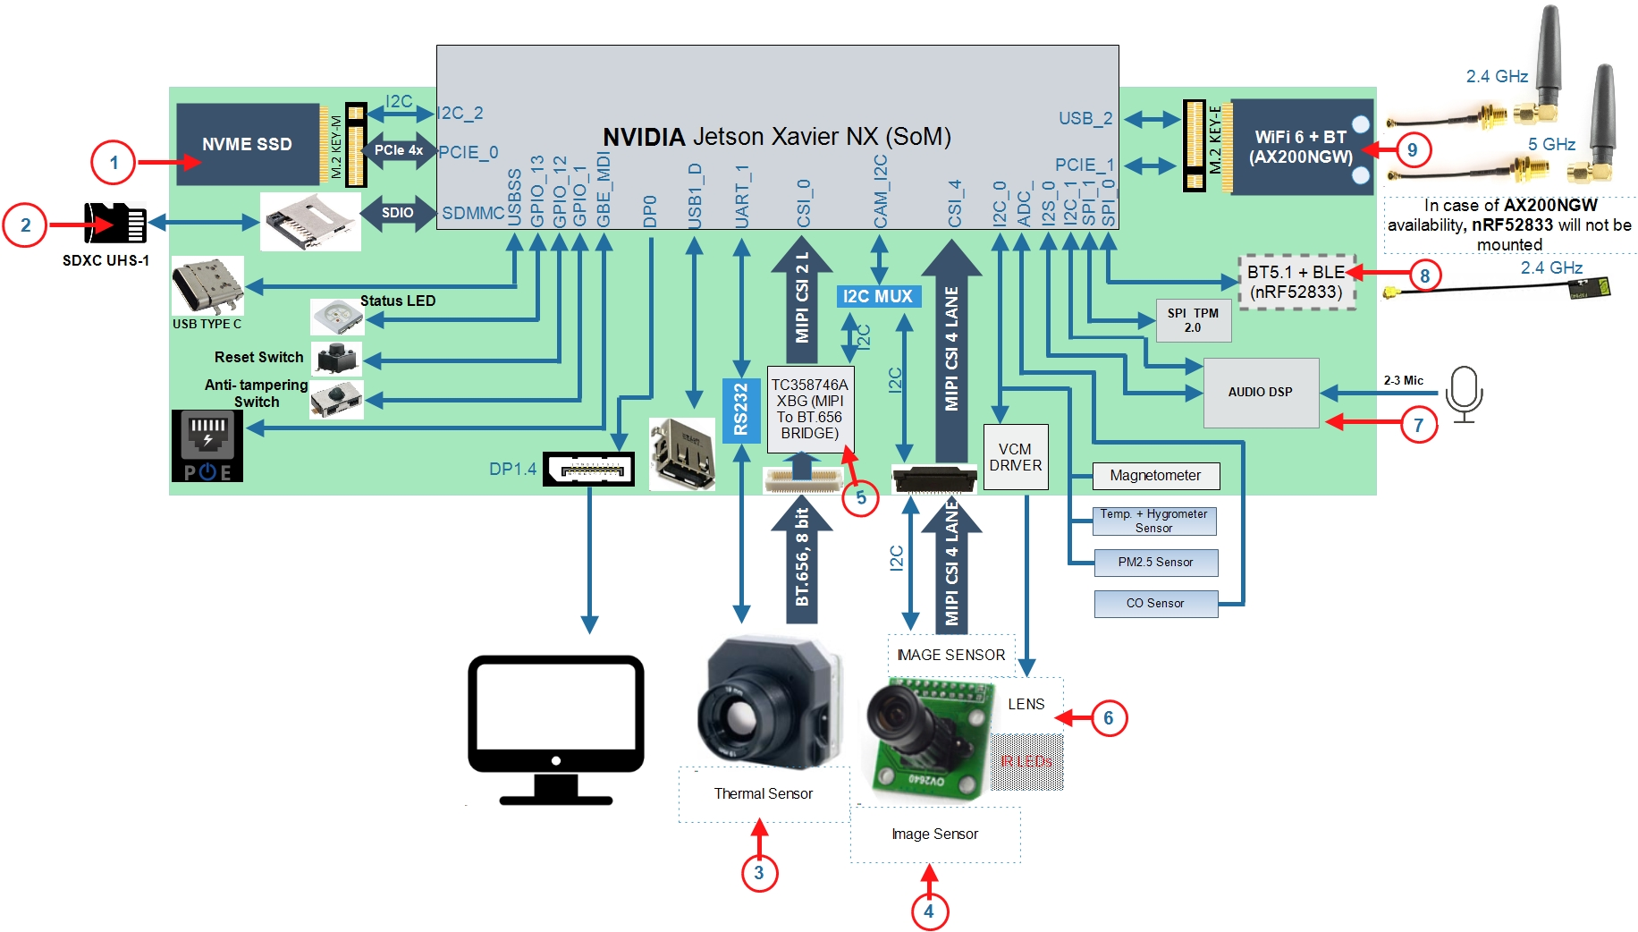

Figure 1: ANCS_SCAM (WiFi 6 Version)

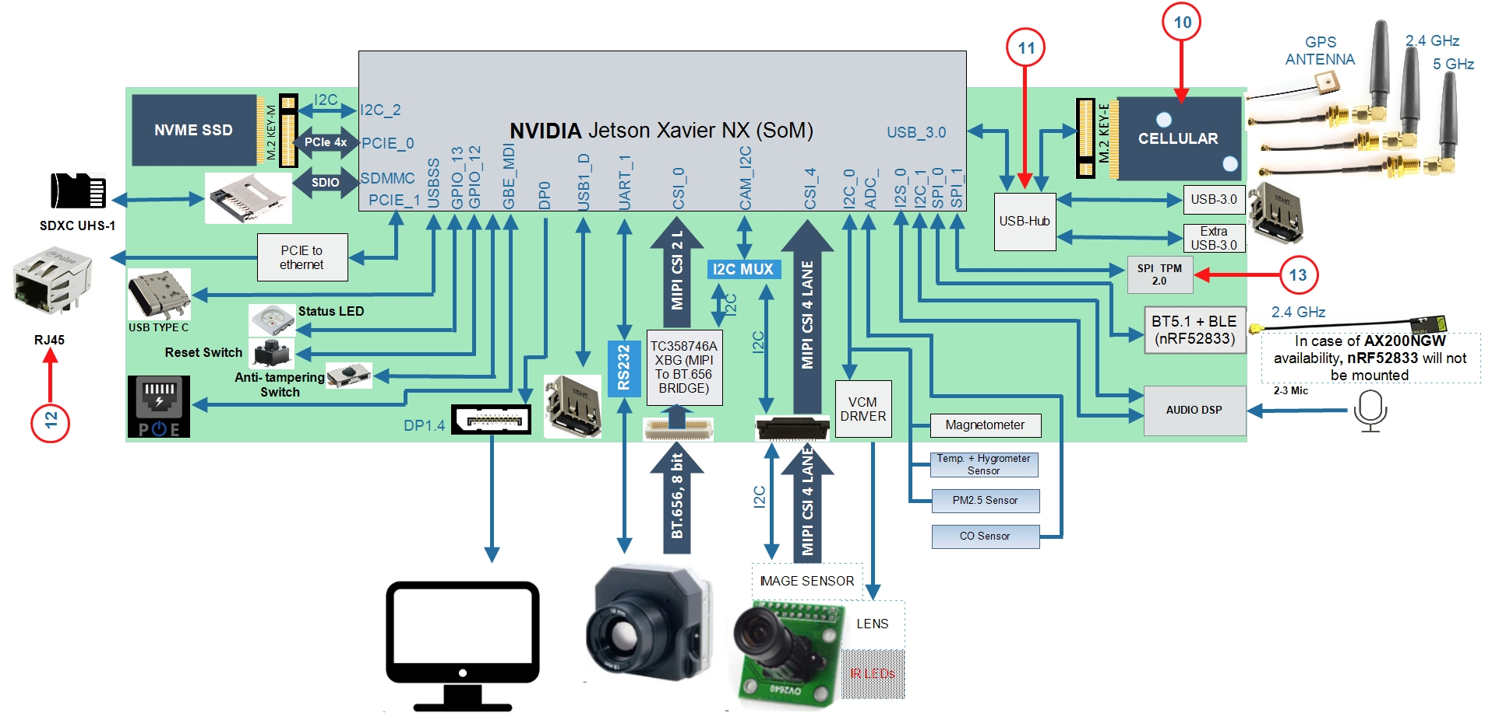

Figure 2: ANCS_SGAT (Cellular Version)

1. NVME SSD Options: WESTERN DIGITAN PC SN730, Micron 2300 SSD
2. SD CARD Options: SDSDQAF3-008G-I, SDC10G2/128GB
3. Thermal Camera Option: Tau 2 336
4. Image Sensor Options: AR1335 (ON Semi)
5. BT.656 to MIPI CSI Convetrer Options: TC358746AXBG
6. Optical Lens: I2C Interface
7. AUDIO DSP: MICROSEMI ZL38063
8. BLE SoC: Nordic nRF52833, Silicon Labs EFR32MG21
9. WiFi Module: ST60-2230C-PU
10. Cellular Module Options: RM500Q, RM510Q, FN980m, FM150
11. USB Hub: RTS5489
12. PCI to ethernet controller – RTL8111H(S)-CG
13. TMP 2.0 – ATTPM20P

Question: We required an ADC pin to connect a CO sensor. Please suggest the ADC pin.

