The Nvidia carrier board was strapped for auto-power operation (CHARGER_PRSNT# tied to ground)
The scope capture below shows four signals. From bottom to top they are:
- The input power to the carrier board.
- The signal VIN_PWR_BAD# (goes high about 44 mS after power is applied)
- CARRIER_PWR_ON (goes high about 198 mS after power is applied)
- Carrier board 1.8 Volt power supply.
The TX2 on the carrier board boots normally, consuming about 3.7 Watts of power while booting and then idling at about 2.8 Watts

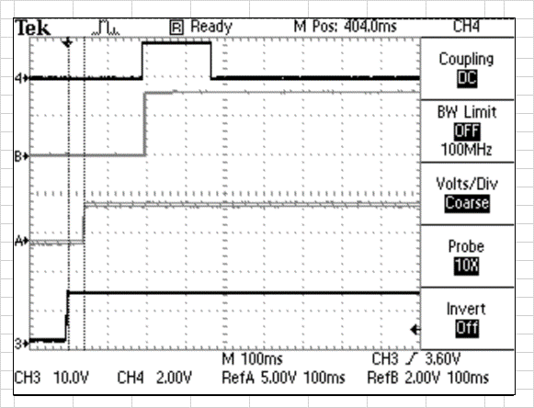

The scope capture below was taken with the exact same signals on my carrier board.
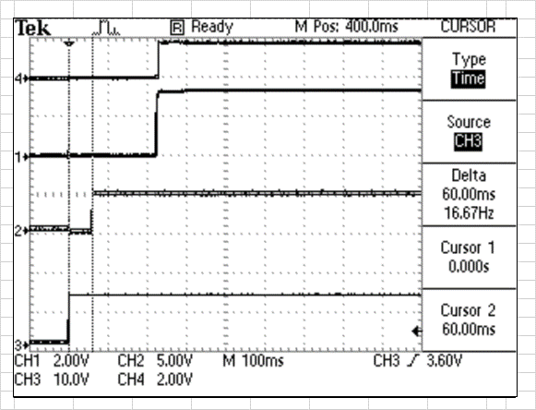
The difference is that the TX2 only draws about 1.3 Watts and does not boot at all. No activity is seen on the debug UART0_TXD line. The other interesting difference is that the 1.8 VDC stays high on my board while on the Nvidia board it goes back low. However, the 5.0V and the 3.3V lines on the Nvidia board stay high.

